
EUROPEAN AND MEDITERRANEAN PLANT PROTECTION ORGANIZATION

ORGANISATION EUROPEENNE ET MEDITERRANEENNE POUR LA PROTECTION DES PLANTES

18-23433 (17-22405)
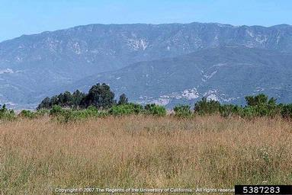
Pest risk assessment for Ehrharta calycina

2018
EPPO
21 Boulevard Richard Lenoir
75011 Paris
www.eppo.int
hq@eppo.int

This pest risk assessment scheme has been specifically amended from the EPPO Decision-Support Scheme for an Express Pest Risk Analysis document PM 5/5(1) to incorporate the minimum requirements for risk assessment when considering invasive alien plant species under the EU Regulation 1143/2014. Amendments and use are specific to the LIFE Project (LIFE15 PRE FR 001) ‘Mitigating the threat of invasive alien plants to the EU through pest risk analysis to support the Regulation 1143/2014’.

Photo:

The pest risk assessment for Ehrharta calycina has been performed under the LIFE funded project:



LIFE15 PRE FR 001

Mitigating the threat of invasive alien plants to the EU through pest risk analysis to support the Regulation 1143/2014

In partnership with

EUROPEAN AND MEDITERRANEAN PLANT PROTECTION ORGANIZATION

And

NERC CENTRE FOR ECOLOGY AND HYDROLOGY



Review Process

- This PRA on Ehrharta calycina was first drafted by Vernon Visser

- The PRA was evaluated under an expert working group at the EPPO headquarters between 2017-01-16/20

- Following the finalisation of the document by the expert working group the PRA was peer reviewed by the following:

(1) The EPPO Panel on Invasive Alien Plants (February and March 2017)
(2) The EPPO PRA Core members (April 2017)
(3) The EU Scientific Forum (2018)

Approved by the IAS Scientific Forum on 26/10/2018

Contents
Summary 6
Stage 1. Initiation 9
Stage 2. Pest risk assessment 11
1. Taxonomy 11
2. Pest overview 11
3. Is the pest a vector? 15
4. Is a vector needed for pest entry or spread? 15
5. Regulatory status of the pest 15
6. Distribution 16
7. Habitats and where they occur in the PRA area 19
8. Pathways for entry 20
9. Likelihood of establishment in the natural environment in the PRA area 24
10. Likelihood of establishment in managed environment in the PRA area 25
11. Spread in the PRA area 25
12. Impact in the current area of distribution 26
12.01 Impacts on biodiversity 26
12.02. Impact on ecosystem services 28
12.03. Socio-economic impact 29
13. Potential impact in the PRA area 29
13.01. Potential impacts on biodiversity in the PRA area 29
13.02. Potential impact on ecosystem services in the PRA area 30
13.03 Potential socio-economic impact in the PRA area 30
14. Identification of the endangered area 30
15. Climate change 31
15.01. Define which climate projection you are using from 2050 to 2100 31
15.02. Which component of climate change do you think is the most relevant for this organism? 31
15.03. Consider the influence of projected climate change scenarios on the pest. 31
16. Overall assessment of risk 32
17. Uncertainty 35
18. Remarks 35
19. REFERENCES 36
Appendix 1: Projection of climatic suitability for Ehrharta calycina establishment 41
Appendix 2. Biogeographic regions in Europe 52
Appendix 3. Relevant illustrative pictures (for information) 53
Appendix 4: Distribution summary for EU Member States and Biogeographical regions 55
Appendix 5 Distribution maps for Ehrharta calycina 56

EUROPEAN AND MEDITERRANEAN PLANT PROTECTION ORGANIZATION

LIFE EWG on invasive plants Ehrharta calycina and Andropogon virginicus
Paris (FR), 2017-01-16/20

PARTICIPANTS

ALBA Christina (Ms) | University of Florida, Gainesville, United States, calba@ufl.edu
CHAPMAN Daniel (Dr) | Centre for Ecology and Hydrology Bush Estate, Penicuik, Edinburgh , UK  Tel: +44 (0)131 4458549 – dcha@ceh.ac.uk
 | Austrian Agency for Health and Food Safety (AGES), Institute for Sustainable Plant Production, Spargelfeldstrasse 191, A-1220 Vienna, Austria- swen.follak@ages.at
  FOLLAK | Swen (Mr)
FROHLICH Danielle (Ms) | c/o SWCA Environmental Consultants -Bishop Square: ASB Tower, 1001 Bishop Street, Suite 2800, 96813 Honolulu, Hawaiʽi, United States, dfrohlich@swca.com
PESCOTT Oliver (Mr) | Centre for Ecology & Hydrology Wallingford, Maclean Building, Benson Lane, Crowmarsh Gifford, OX10 8BB Wallingford, Oxfordshire, United Kingdom, olipes@nerc.ac.uk
VAN VALKENBURG Johan (Mr) | National Plant Protection Organization, Geertjesweg 15, P.O. Box 9102, 6700 HC Wageningen, Netherlands, j.l.c.h.van.valkenburg@minlnv.nl
VISSER Vernon (Mr) | Department of Statistical Sciences University of Cape Town, Stellenbosch, South Africa, vervis@gmail.com
TANNER Rob (Mr) | OEPP/EPPO, 21 boulevard Richard Lenoir, 75011 Paris, France  Tel: +33-145207794 - rt@eppo.int

Summary of the Express Pest risk assessment for Ehrharta calycina
PRA area: EPPO region
Describe the endangered area:
The species has established in the Mediterranean and Atlantic biogeographical regions of Europe. Based on the current distribution modelling of the species, the endangered area is the west and south of the PRA area, particularly in the Iberian Peninsula, North Africa, and limited areas of the Mediterranean (see Appendix 1). The highest potential for establishment is in North African countries (Algeria, Morocco, Tunisia), France (Corsica), Portugal, Italy (limited areas of Sardinia, Sicily) and Spain. Limited areas of Turkey are also highlighted (Appendix 1). Although it has invaded Mediterranean regions around the world, the Expert Working Group note that E. calycina is known to establish outside of these climate regions (for example in high elevations in pasture and cinder cone habitats in Hawaiʽi and natural areas in South Africa) and the modelling (maps) in Appendix 1 may underestimate the potential area of invasion.

Habitats within the endangered area include those with sandy soils, shrubland and open-woodland, and disturbed environments such as roadsides and pastures.
Main conclusions
Ehrharta calycina poses a moderate phytosanitary risk to the endangered area with a moderate uncertainty. A moderate risk score has been given based on the low likelihood of entry, coupled with the high risk of establishment and high negative impacts on biodiversity and ecosystem services. The species occurs in Portugal, Spain and Tunisia and there is some circumstantial evidence the species has spread within the region. Compared to California and Australia, the occurrences in the EPPO region are relatively recent and therefore the species may still be in the lag phase (i.e. the full extent of the invasion may not yet be realised).

Entry and establishment
In the EPPO region, E. calycina is reported in Portugal, Spain and Tunisia. In Tunisia, the species was introduced as a forage crop but it is uncertain how the species entered Portugal and Spain. The overall likelihood of new introductions into the EPPO region is low with a moderate uncertainty. The low score highlights the fact that the only pathways identified are (1) seeds for planting and (2) hay imports. In the case of the former evidence for commercial use in the EPPO region is lacking and for the latter there have been no interceptions along this pathway.

Potential impacts in the PRA area
All the information on impacts is based on data from outside of the EPPO region and thus can only be a proxy to the potential impacts within the EPPO region. In other invasive regions, E. calycina has been recorded as degrading biological diversity (both flora and fauna). The species can negatively impact on ecosystem services by being a habitat transformer (provisioning services), can increase fire frequencies (regulating), change nutrient cycling (supporting), and degrade the aesthetical value of habitats (cultural).

Ehrharta calycina is very likely to have similar impacts in the PRA area as in Australia and California (EWG opinion). Sandy habitats, shrub and rangelands in the Mediterranean region of the PRA area are environmentally very like those in Australia and California where this species has had the most impacts. Moreover, E. calycina seems to have been introduced much earlier in Australia and California (~1900 and ~1940 respectively) than in parts of the PRA area (Portugal and Spain), providing less time for the establishment and spread of this species. There was also seemingly much lower introduction effort (in terms of propagule pressure) in the PRA area. For example, in California this species was promoted by the Soil Conservation Service (Pickart, 2000).

If E. calycina initiates a grass-fire cycle and/or forms monospecific stands as observed in Australia and California, then impacts on biodiversity are likely to be large, with the displacement of native plant species and a reduction in habitat for dune-, shrubland- or woodland-specialist fauna (EWG opinion).

Impacts of Ehrharta calycina in the PRA region have not been investigated at all and in other regions where the species is invasive there is also not much impact-specific literature However, the potential impacts on ecosystem services in the PRA region are likely to be the same as those observed, or thought to exist, in other parts of the world. The largest potential impact on ecosystem services is probably on the regulatory services of natural hazard regulation and biodiversity. A low score has been given for potential socio-economic impacts based on a current lack of data.

The text on impacts in the PRA area relates equally to EU Member States and non-EU Member States in the EPPO region.

Climate change
By the 2070s, under climate change scenario RCP8.5, almost no parts of southern Europe and the Mediterranean region are predicted to remain or become suitable for E. calycina. Examination of the future climate scenario data suggest that this is driven by an increase in maximum temperature of the warmest month to levels at which the model suggests it can limit occurrence of the E. calycina. The only part of Europe predicted to retain climatic suitability is the Canary Islands. In northern Europe suitability is predicted to increase by the 2070s, but largely remain marginally unsuitable for E. calycina. The small pocket of Germany predicted as currently suitable is predicted to remain so in the 2070s and small pockets of suitable climates now appear in south eastern UK, and the south eastern coast of Sweden. These small areas of marginal suitability are present in the Continental, Atlantic and Boreal biogeographical regions. The influence of projected climate change scenarios has not been taken into account in the overall scoring of the risk assessment based on the high levels of uncertainty with future projections.

The results of this PRA show that Ehrharta calycina poses moderate risk to the current and projected endangered area (Mediterranean and Atlantic biogeographical) with a moderate uncertainty.

Given the impact of the species in other parts of the world and the identified risk to the PRA area, the Expert Working Group recommends the following measures for the endangered area:

Phytosanitary risk (including impacts on biodiversity and ecosystem services) for the endangered area (current/future climate)  Pathways for entry  Plants for planting (fodder): Low/Low  Plants for planting (erosion control): Low/Low  Import of hay: Low/Low  Likelihood of establishment in natural areas: High/High  Likelihood of establishment in managed areas: High/High  Spread: Moderate/Moderate  Impacts (PRA area)  Biodiversity and environment: High/High  Ecosystem services: High/High  Socio-economic: Low/Low | High | Moderate  X | Low
Level of uncertainty of assessment (current/future climate)  Pathways for entry  Plants for planting (fodder): Moderate/Moderate  Plants for planting (erosion control): Moderate/Moderate  Import of hay: High  Likelihood of establishment in natural areas: Low/High  Likelihood of establishment in managed areas: Low/High  Spread: High/High  Impacts (PRA area)  Biodiversity and environment: High/High  Ecosystem services: High/High  Socio-economic: High/High | High | Moderate  X | Low
Other recommendations:
- Surveys should be conducted to confirm the current distribution and status of the species within the endangered area.

- Data sharing should be encouraged across the EPPO region.

- Contact land-managers and local botanists, where the species occurs, to attain further information on the species.

Express Pest risk assessment:
…………..
(Ehrharta calycina)
Prepared by:
First draft: Vernon Visser, SEEC (Centre for Statistics in Ecology, the Environment and Conservation), University of Cape Town, South Africa. Email: vervis@gmail.com

Date:
2/1/2017

Stage 1. Initiation

Reason for performing the PRA:
Ehrharta calycina has a limited distribution in the EPPO region restricted to parts of Portugal (GBIF, 2016), Spain (GBIF, 2016; Valdés et al., 1987; Valdés, 2015). However, E. calycina is naturalised in Spain in the Doñana area (Valdés, 2015). It is also present in the EPPO region in Tunisia (Greuter & Raus, 1998; Le Floch et al., 2010). Outside of the EPPO region, this species is invasive in Mediterranean-climate areas of California (Pickart, 2000) and Australia (Fisher et al., 2006) and in New Zealand (Edgar & Connor, 2000; Frey, 2005). It has also been introduced into Chile (Pizarro, 1959), Hawaiʽi (Wagner et al., 1999), Texas (Jones et al. 1997; USDA, NRCS, 2016) and Uruguay (Rosengurtt et al., 1970). In Australia and California this species is associated with the conversion of native woodland into E. calycina-dominated grasslands, either by suppressing the growth of native plants or via a positive-feedback cycle in which this grass promotes more frequent fires, which in turn suppress native plants and further promote a higher abundance of E. calycina (the so-called “grass-fire” cycle; D’Antonio & Vitousek, 1992; Fisher et al., 2009; Pickart, 2000). E. calycina is also implicated in a change in nutrient cycling, specifically of phosphorous, in Australian Banksia woodlands (Fisher et al., 2006). In its native range in the Mediterranean-type climate area of South Africa, E. calycina is known to be a weedy species and dominates areas cleared of nitrogen-fixing Australian Acacia species (Yelenik et al., 2004). Although it is not known how E. calycina arrived in the EPPO region including Europe, in Australia and California this species was intentionally introduced as a forage and possibly also arrived as a contaminant in imported forage in Australia (Pickart, 2000; Rossiter, 1947). Consequently, the reason for performing a PRA for E. calycina is because of its potential impacts and its large potential range in the Mediterranean biogeographical region.’ In 2016, the species was prioritized (along with 36 additional species from the EPPO List of Invasive Alien Plants and a recent horizon scanning study) for PRA within the LIFE funded project “Mitigating the threat of invasive alien plants to the EU through pest risk analysis to support the Regulation 1143/2014’.

PRA area: EPPO region (see https://www.eppo.int/ABOUT_EPPO/images/clickable_map.htm)

The risk assessments were prepared according to EPPO Standard PM5/5 (slightly adapted) which has been approved by the 51 EPPO Member Countries, and which sets out a scheme for risk analysis of pests, including invasive alien plants (which may be pests according to the definitions in the International Plant Protection Convention). EPPO engages in projects only when this is in the interests of all its member countries, and it was made clear at the start of the LIFE project that the PRA area would be the whole of the EPPO region. Furthermore, we believe that since invasive alien species do not respect political boundaries, the risks to the EU are considerably reduced if neighbouring countries of the EPPO region take equivalent action on the basis of broader assessments and recommendations from EPPO.

All information relating to EU Member States is included in the Pest risk assessment and information from the wider EPPO region only acts to strengthen the information in the PRA document. The PRA defines the endangered area where it lists all relevant countries within the endangered area, including EU Member States. The distribution section lists all relevant countries in the EPPO region (including by default those of EU Member States and biogeographical regions which are specific to EU member States). Habitats and where they occur in the PRA are defined by the EUNIS categorization which is relevant to EU Member States. Pathways are defined and relevant to the EU Member States and the wider EPPO Member countries, and where the EWG consider they may differ between EU Member States and non-EU EPPO countries, this is stated. The establishment and spread sections specifically detail EU Member States. When impacts are relevant for both EU Member States and non-EU EPPO countries this is stated ‘The text within this section relates equally to EU Member States and non-EU Member States in the EPPO region’. Where impacts are not considered equal to EU Member States and non-EU Member States this is stated and further information is included specifically for EU member States. For climate change, all countries (including EU Member States) are considered.

Stage 2. Pest risk assessment
1. Taxonomy:
Ehrharta calycina Sm. (Kingdom Plantae; Phylum Tracheophyta; Class Liliopsida; Order Poales; Family Poaceae; Genus Ehrharta).

EPPO code: EHRCA

Common names: Perennial veldt grass, purple veldt grass, veldt grass, common ehrharta, gewone ehrharta (Afrikaans), rooisaadgras (Afrikaans).

Synonymy: Aira capensis L. f., Ehrharta adscendens Schrad., Ehrharta auriculata Steud., , Ehrharta geniculata Thunb., Ehrharta laxiflora Schrad., Ehrharta laxifolia Schrad., Ehrharta melicoides Willd. ex Nees [Invalid], Ehrharta nutans Willd. ex Nees [Invalid], Ehrharta ovata Nees, Ehrharta paniculata Poir., Ehrharta pilosa Willd. ex Steud. [Invalid], Ehrharta ramosa Willd. ex Nees [Invalid], Ehrharta stricta Nees, Ehrharta undulata Nees ex Trin., Ehrharta versicolor Schrad., Melica geniculata Thunb., Trochera auriculata (Steud.) Kuntze, Trochera calycina (Sm.) P.Beauv., Trochera geniculata (Thunb.) Kuntze, Trochera laxiflora (Schrad.) Kuntze, Trochera melicodes Kuntze, Trochera ovata (Nees) Kuntze, Trochera stricta (Nees) Kuntze, Trochera versicolor (Schrad.) Kuntze
Ref: The Plant List (http://www.theplantlist.org/tpl1.1/record/kew-410473)

Plant type: Perennial grass

Related native species in the EPPO region: None

Related non-native species in the EPPO region: Ehrharta erecta Lam. recorded as naturalised in the Mediterranean biogeographical region (Galasso et al., 2018) and in Ireland (Dublin) (pers. comm. O. Pescott, 2018).

Related species in trade in the EPPO region: None

2. Pest overview
Introduction
Ehrharta calycina is a grass species native to South Africa and southern Namibia (Fish et al., 2015). It usually has a perennial life history, but sometimes occurs as an annual (Fish et al., 2015). It is a tufted rhizomatous grass that primarily reproduces from seed (Fish et al. 2015; Mashau, 2008; Wittkuhn, 2010). Seeds are abundantly produced and primarily dispersed by wind (Bossard et al., 2000; Wittkuhn 2010). This species has been introduced into Australia, India, New Zealand, Portugal, Spain, Tunisia, Chile, Uruguay, and the USA (including Hawaiʽi), and has been shown to be problematic in Australia and California in the USA (Frey, 2005; Pickart, 2000).

Environmental requirements
Ehrharta calycina appears to have fairly broad environmental tolerance. It occurs in areas with mean annual precipitation ranging from 200 mm to over 800 mm and in areas with precipitation seasonality varying from almost exclusively in winter to almost exclusively in summer (Hoare, 2016). It is fire, frost and drought tolerant (HerbiGuide, 2016; Western Australian Herbarium, 2016). The species has been documented in areas in South Africa with very low rainfall (Mucina et al., 2006). As part of experiments to identify plants suitable for vegetating mine tailings, it was found that E. calycina is fairly tolerant of high aluminium concentrations (Edmeades et al., 1991). It prefers sandy soil textures, but can grow in most soils (Mashau, 2008; Moore et al., 2006). CABI (2016) details that the soil tolerance for the species is free drainage, acidic to neutral soils with light texture. However, E. calycina is intolerant of waterlogging, and it cannot tolerate heavy grazing (HerbiGuide, 2016; Moore et al., 2006; Rossiter, 1947; van der Westhuizen & Joubert, 1983) nor high salinity levels Western Australian Herbarium (1998).

Habitats
In its native range, E. calycina occurs in a range of habitats (Fish et al., 2015; Hoare, 2016), but it is most common in sandy soils and disturbed areas (Mashau, 2008). In California, this species is common on sandy substrates, invading dunes and shrublands, but is present in a variety of habitats, including dunes, dune scrub, maritime chaparral, coast live oak woodlands, coastal grasslands and coastal sage scrub (Bossard et al., 2000; CAL-IPC, 2016). In Australia, it invades Banksia woodlands on sandy soils (Western Australian Herbarium, 2016), and is also found in other woodlands, along waterways and wetlands and in disturbed environments (Biosecurity Queensland, 2016). In Spain, it has been found in dunes and dry pastures (Valdés et al., 1987), in Portugal along roadsides and open woodland (GBIF, 2016), and in Tunisia in pastures (Greuter & Raus, 1998). In New Zealand, this species has been reported mostly in sandy areas, pastures and in pine plantations (Frey, 2005).

Identification
A very variable species that has many described ecotypes or regional variants suggesting that it represents a species complex (Fish et al., 2015). It is a tussock grass, with culms generally varying in height from 30 to 70 cm high (but can reach up to 180 cm) (Fish et al., 2015) and has creeping, branched rhizomes (Mashau, 2008). Leaves are often red to purple tinged, up to 7 mm in width, flat or rolled, often wrinkled along the blade margin and filiform in shape (CAL-IPC, 2016; Fish et al., 2015). Inflorescences (panicles) are red in colour and may be produced at any time of the year, but usually in spring (Fish et al., 2015; Valdés et al., 1987).

Further details are included below to distinguish E. calycina from E. erecta. (eds: Baldwin et al., 2012)

Ehrharta calycina
Stem: generally 30--75 cm, erect, glabrous. Leaf: sheath generally smooth, +- purple, auricles ciliate; ligules +- 1 mm; blade 5--20 cm, < 1 cm wide. Inflorescence: panicle-like, 5--25 cm, +- open, sometimes nodding or partly enclosed in upper sheaths; spikelets subsessile to stalked, stalk < 5 mm, +- thread-like. Spikelet: 4--8 mm; glumes 3--7 mm, +- equal, > sterile florets, becoming +- purple; sterile lemmas soft-hairy, upper auricled; fertile lemma 5--7-veined, veins glabrous or hairy, awn 0; palea < lemma; stamens 6.

Ehrharta erecta
Stem: 4--10 mm, erect or ascending, sometimes rooting from lower nodes. Leaf: sheath striate, glabrous or hairy; ligule to 3 mm; blade 5--15 cm, 4--15 mm wide, flat, generally glabrous, margins often wavy. Inflorescence: panicle-like, 6--20 cm, generally open, erect or nodding; spikelets sessile to subsessile, stalk generally < 1 mm, stiff. Spikelet: 3--6 mm; glumes 1.5--4 mm, +- equal, > sterile florets, 3--5-veined, +- green at maturity; sterile lemma 2.5--4.5 mm, +- glabrous, awn 0, lower generally auricled, upper transversely wrinkled; fertile lemma 2.5--3.5 mm, glabrous, faintly 5--7-veined, tip obtuse, awn 0; palea 2-veined; stamens 6.

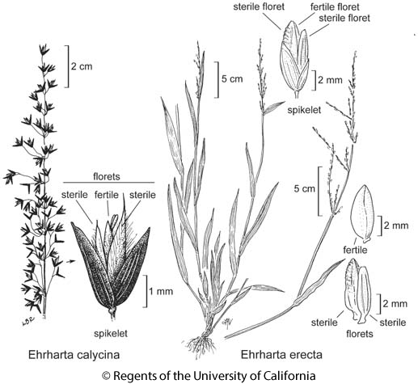
Image of Ehrharta calycina and E. erecta showing differences in morphology of spikelet and florets.
Symptoms
In California and Australia, E. calycina can dominate plant communities, excluding native plant species and transforming shrubland into grasslands (Fisher et al., 2009; Frey, 2005; Milberg & Lamont, 1995; Pickart, 2000). This species can form monospecific stands by suppressing the germination of native species through rapid growth and shading out of native plant seedlings (Pickart, 2005). E. calycina can initiate an enhanced grass-fire cycle, promoting more frequent fires, which in turn favour this fire-adapted species at the expense of native plant species (Fisher et al., 2009; Milberg & Lamont, 1995). In eutrophic Australian Mediterranean-type environments, E. calycina has been shown to cause a shift in phosphorous nutrient cycling, with vegetation transformation coinciding with a shift of phosphorus from biomass to soils (Fisher et al., 2006).

Relevant PRAs
Australia:
Using the Victorian Weed Risk Assessment method, The State of Victoria (2016) found E. calycina to be most likely to have high impacts by reducing native plant biomass and changing community composition and structure. It was also found to have a medium/high risk of affecting native flora and fauna and also for providing food for non-native pests such as rabbits. The Victorian Weed Risk Assessment method gave E. calycina an overall high rating with high uncertainty.

California:
Using the CAL-IPC Criteria for Categorizing Invasive Non-Native Plants that Threaten Wildlands, Roye (2004) gave E. calycina a “high” overall score, which means this species has a high level of threat to the ecological health of Californian wildlands. This species was found to have severe impacts on abiotic system processes and plant communities. Its establishment is strongly influenced by anthropogenic and natural disturbances and it was rated as having a wide “ecological amplitude”, which means it can tolerate a broad variety of environments.

Europe:
Ehrharta calycina was assessed using a horizon scanning approach to produce a ranked list of 95 invasive alien species that will be used to inform the European Union Regulation (EU) no. 1143/2014 on invasive alien species (Roy et al., 2015). This species scored high for the likelihood of arrival, establishment, spread of and impact in the EU, giving it an overall “high risk” (one rank below the highest category = very high risk). E. calycina was assessed to have a high risk of competing with native plants, altering nutrient cycling and modifying habitats.

Hawaiʽi:
Chimera (2015) gave this species a high-risk score of 18, which is in the top 10 % highest scores of 1816 species assessed using the Hawaiʽi-Pacific Weed Risk Assessment system. E. calycina is a possible problematic invader in Hawaiʽi because of its potential to alter fire regimes, the fact that seeds are wind-dispersed and that it is a palatable grass used for forage.

Socio-economic benefits
Ehrharta calycina is a valuable forage grass (Hoare, 2016; Quattrocchi, 2006), but it is not known if it is actively cultivated or sold as such within the EU territory. It was introduced in Tunisia the 1970s as a forage species Greuter & Raus (1998)). The species has been used for mine tailing rehabilitation and for revegetation purposes (Pauw, 2011; Quattrocchi, 2006; Schmalzer & Hinkle, 1987). E. calycina has been promoted for erosion control and landscaping in the USA.

3. Is the pest a vector? | Yes | X
Ehrharta calycina has been reported to be a vector of yellow dwarf virus in Australia, a virus that affects wheat, barley and oats (Jones et al., 1990). The smut fungus, Tilletia ehrhartae, native to South Africa and highly host-specific to Ehrharta calycina has been found in Australian and Californian populations of this grass (Piątek et al., 2015). The smut fungus was not intentionally released as a biological control agent in these regions.

4. Is a vector needed for pest entry or spread? | No | X

5. Regulatory status of the pest

E. calycina is not regulated anywhere in the world.

6. Distribution
Continent | Distribution (list countries, or provide a general indication , e.g. present in West Africa) | Provide comments on the pest status in the different countries where it occurs (e.g. widespread, native, non-native, established….) | Reference
Africa | South Africa and southern Namibia. | Native | Fish et al. (2015)
 | Tunisia. | Introduced and naturalised, but not widespread. Only known from one locality near Cap Serrat. | Greuter & Raus (1998); Le Floch (2010); Von Raab and Raus (2017)
 | Egypt | Introduced | Ibrahim et al (2016)
America | Chile | Introduced and naturalised in two localities, Ovalle and Cauquenes. | Pizarro (1959)
 | Uruguay | Uncertain. | Rosengurtt et al. (1970)
 | California. | Introduced, established and invasive. | Pickart (2000)
 | Nevada | Introduced. | Barkworth et al. (2007)
 | Texas | Uncertain. | Barkworth et al. (2007); Jones et al. (1997)
 | Hawaiʽi | Casual or unknown | Bishop Museum, 1997, 2004
Asia | India | Reported to be naturalised. | USDA (2016) NGRP (2016)
Europe | Portugal  Biogeographical region:  Mediterranean | Naturalised, including recent records (2015) and mostly from roadsides. | Bacelar & al. (1989), GBIF (2016)
 | Spain (mainland and Menorca)  Biogeographical region:  Mediterranean | Naturalised. | Charpin and Zarco (1982) ,  Valdés (2015); Fraga-Arguimbau (2014)
Oceania | Australia: New South Wales, South Australia, Tasmania, Victoria, Western Australia | Introduced, established and invasive on sandy soils in woodlands in the Mediterranean-climate region of south-western Australia and in south-eastern South Australia. | Fisher et al. (2006, 2009); HerbiGuide (2016)
 | New Zealand: North Island | Introduced, established and invasive on sand dunes, sandy places and pine plantations in Auckland, Manawatu and Wairarapa. | Edgar & Connor (2000)

Introduction
Ehrharta calycina is a grass species native to South Africa and southern Namibia (Fish et al., 2015). It is invasive in California, Australia and New Zealand and has naturalised in Chile, India, Portugal, Spain and Tunisia. It has also been introduced into Nevada, Texas and Uruguay (See Appendix 5, Figure 1).

Africa
E. calycina has a native range extending from the extreme southern winter-rainfall parts of Namibia, through the south-west and southern parts of South Africa and up into the east of the country in KwaZulu-Natal (Fish et al., 2015). However, it is most abundant in the south-western Cape of South Africa (Mashau, 2008). Elsewhere in Africa, this species is only known to occur in Tunisia, where it was planted as a forage crop and escaped into nearby land near Cap Serrat (Greuter & Raus, 1998) and in Egypt. See Appendix 5, Figure 2. It was very likely also introduced in the past in Morocco (http://gallica.bnf.fr/ark:/12148/bpt6k9745401z/f100.image.r=%22Ehrharta%20calycina%22?rk=21459;2).

Americas
First introduced into California in 1928 as forage seed, E. calycina became established here in about 1930 (Pickart, 2000). This species was actively spread throughout California in the 1950s and 1960s by the Soil Conservation Service of the time, being promoted as a forage crop and for erosion control (Pickart, 2000). Currently E. calycina is invasive in a number of coastal counties and further inland in Yolo county in California (Pickart, 2000). Elsewhere in the USA, this species is known to occur in Nevada and Texas (Barkworth et al., 2007). However, the reference for Texas is an old reference (1950s) and the species has not been collected since. In Hawaiʽi, there are two records for the species, one in an agricultural experiment station (on Maui) and another in an army training camp (Big Island) (Bishop Museum, 1997, 2004). E. calycina has also been reported in a Uruguayan flora, but the current status of this species is uncertain (Rosengurtt et al., 1970). It was also introduced into Chile as a forage crop and has naturalised in two localities (Ovalle and Cauquenes) (Pizarro, 1959). See Appendix 5, Figure 3.

Asia
E. calycina has been reported as being naturalised in India, but little other information on its distribution or status here is available (USDA, 2016).

Europe
E. calycina is only known to occur in Portugal and Spain. In Portugal, this species has been recently (2015) observed in a number of new localities near Lisbon (GBIF, 2016). In Spain the species was first recorded in Seville in 1982. In Spain, this species is naturalised in the Doñana area (Valdés, 2015), in dry pastures (Valdés et al., 1987), and has been recorded in the vicinity of Pontevedra and Cañaveral (GBIF, 2016). See Appendix 5, Figure 4.

Oceania
E. calycina was introduced into Australia around 1900 (HerbiGuide, 2016). It now occurs across southern Australia, including Western Australia, South Australia, New South Wales, Victoria and Tasmania (HerbiGuide, 2016). In Western Australia, it is a problematic invader of woodlands on sandy soils and along roadsides and is particularly common in the very south-west of the state (Biosecurity Queensland, 2016). In southern Western Australia E. calycina is also common alongside wetlands and waterways (Biosecurity Queensland, 2016). In south-eastern South Australia, this species is also invasive, particularly around Adelaide and on Kangaroo Island (Biosecurity Queensland, 2016). In New Zealand, this species was first recorded in 1956 at Santoft and has spread to a number of other localities on the North Island (Edgar et al., 1991; Edgar & Connor, 2000). It is reported growing mostly in sandy areas (e.g., dunes), pastures and in pine plantations (Frey, 2005). See Appendix 5, Figure 5 and 6.

7. Habitats and where they occur in the PRA area

Habitat | EUNIS habitat types | Status of habitat | Is the pest present in the habitat in the PRA area | Comments (e.g. major/minor habitats in the PRA area) | Reference
Dunes | B1: Coastal dunes and sandy shores | Protected pro parte: 16.211, 16.212, 16.221, 16.223, 16.224, 16.26, 16.27, 16.28, 16.29, 16.31  Threatened: 16.211, 16.212, 16.221, 16.223, 16.26, 16.27, 16.28, 16.29, 16.31 | Yes | Major | Frey (2005); Pickart (2000); Fraga-Arguimbau (2014)
Temperate heathlands | F7: Spiny Mediterranean heaths (phrygana, hedgehog-heaths and related coastal cliff vegetation) | Protected pro parte: 31.7  Threatened: 31.7 | Yes | Major | Pickart (2000)
Grassland | E1: Dry grassland Volcanic | In part | Yes | Minor | Bishop Museum database, 1997; Valdes et al., 1987
Woodland | G: Woodland, forest and other wooded land | In part | Yes | Major | Fisher et al., 2009; Pinto et al., 2013
Roadsides | J: Constructed, industrial and other artificial habitats  Roadside habitats  J.4.2 Roadside | No | Yes | Major | DiTomaso,et al., 2013; Biosecurity Queensland, 2016

In its native range, E. calycina occurs in a range of habitats (Fish et al., 2015; Hoare, 2016), but it is most common in sandy soils and disturbed areas (Mashau, 2008). In California, this species is common on sandy substrates, invading dunes and shrublands, but is present in a variety of habitats, including dunes, dune scrub, maritime chaparral, coast live oak woodlands, coastal grasslands and coastal sage scrub (Bossard et al., 2000; CAL-IPC, 2016). In Australia, it invades Banksia woodlands on sandy soils (Western Australian Herbarium, 2016), and is also found in other woodlands, along waterways and wetlands and in disturbed environments (Biosecurity Queensland, 2016). In Spain, it has been found in dunes and dry pastures (Valdés et al., 1987), in Portugal along roadsides and open woodland (GBIF, 2016), and in Tunisia in pastures (Greuter & Raus, 1998). In New Zealand, this species has been reported mostly in sandy areas, pastures and in pine plantations (Frey, 2005).

8. Pathways for entry (in order of importance)
Possible pathway | Pathway: Plants for planting  (CBD terminology: Release in nature – other intentional release - fodder)
Short description explaining why it is considered as a pathway | Ehrharta calycina has been planted as a forage plant (Pickart, 2000; Quattrocchi, 2006). The species is available for commercial purposes in Australia. Ehrharta calycina is promoted as a forage grass in Australia and New Zealand. There is no evidence that the species is promoted as a forage grass within EU Member States or the rest of the EPPO region. However, the species was tested as a forage species in Morocco (Jaritz, 1992).
Is the pathway prohibited in the PRA area? | Not currently prohibited in the PRA area.
Has the pest already been intercepted on the pathway? | It is uncertain how this species arrived in Portugal and Spain. Elsewhere in the world this species was planted for forage in Australia, California, and Chile (Pickart, 2000; Pizarro, 1959; Western Australian Herbarium, 1998-). In Tunisia the species was introduced as a fodder and pasture grass, almost certainly as seed (Greuter & Raus, 1998).
What is the most likely stage associated with the pathway? | Seeds are the only stage to be moved via this pathway. However, historically the species may have been introduced into Australia by cuttings Kloot (1987).
What are the important factors for association with the pathway? | In the EPPO region including EU territory, the species does not appear to be readily available from commercial forage seed producers, although there are registered cultivars in Australia and the USA (UPOV, 2016).
Is the pest likely to survive transport and storage along this pathway? | Yes, seeds can survive for prolong periods when dried.
Can the pest transfer from this pathway to a suitable habitat? | Yes, especially since this species was previously marketed as a drought-resistant forage species for sandy areas or for erosion control (Hoare, 2016; Pickart, 2000). This makes it likely for the species to be introduced into sandy habitats to which it is well adapted.
Will the volume of movement along the pathway support entry? | Unknown as sales of the species has not been monitored in the EPPO region.
Will the frequency of movement along the pathway support entry? | Unknown as sales of the species has not been monitored in the EPPO region.
Rating of the likelihood of entry | Low X Moderate ☐ High ☐
Rating of uncertainty | Low ☐ Moderate X High ☐

As the species is imported as a commodity, all European biogeographical regions will have the same likelihood of entry and uncertainty scores.

Possible pathway | Pathway: Plants for planting  (CBD terminology: Release in nature – erosion control)
Short description explaining why it is considered as a pathway | Ehrharta calycina has been planted for erosion control (Pickart, 2000; Quattrocchi, 2006). The species is used for erosion control and seed mixes are sold for this purpose. At present, no information is available if E. calycina is a species used in such mixes. There is no evidence that the species is promoted for erosion control within the EPPO region and Europe in particular.
Is the pathway prohibited in the PRA area? | Not currently prohibited in the PRA area.
Has the pest already been intercepted on the pathway? | No, the species has not been intercepted as a species specifically for erosion control.
What is the most likely stage associated with the pathway? | Seeds are the only stage to be moved via this pathway.
What are the important factors for association with the pathway? | The species is used for erosion control and seed mixes are sold for this purpose. At present, no information is available if E. calycina is a species used in such mixes.
Is the pest likely to survive transport and storage along this pathway? | Yes, seeds can survive for prolong periods when dried.
Can the pest transfer from this pathway to a suitable habitat? | Yes, especially since this species was previously marketed as a drought-resistant for erosion control (Hoare, 2016; Pickart, 2000). This makes it likely for the species to be introduced into sandy habitats to which it is well adapted.
Will the volume of movement along the pathway support entry? | Unknown as sales of the species has not been monitored in the EPPO region.
Will the frequency of movement along the pathway support entry? | Unknown as sales of the species has not been monitored in the EPPO region.
Rating of the likelihood of entry | Low X Moderate ☐ High ☐
Rating of uncertainty | Low ☐ Moderate X High ☐

The entry pathway will be more likely for the Mediterranean biogeographical region.

Possible pathway | Pathway: Contaminant of hay imports  (CBD terminology: Transport contamination – transportation of habitat material)
Short description explaining why it is considered as a pathway | Although there is no published evidence of E. calycina being transported as part of hay material from the USA (California) there is evidence that hay is imported into the EU (see https://apps.fas.usda.gov/gats/default.aspx) and potentially seed material of E. calycina may be included. Hay imports into Alaska have resulted in viable grass seed being intercepted with the commodity (see Conn et al., 2010).
Is the pathway prohibited in the PRA area? | Regulations on the import of hay into Europe and the EPPO region based on animal and plant legislation is unclear.
Has the pest already been intercepted on the pathway? | No. E. calycina has not been intercepted in hay imports globally.
What is the most likely stage associated with the pathway? | Seeds are the most likely stage associated with this pathway.
What are the important factors for association with the pathway? | E. calycina grows in pasture habitats in California and could become incorporated into plant material used for hay production.
Is the pest likely to survive transport and storage along this pathway? | Yes.
Can te pest transfer from this pathway to a suitable habitat? | Yes, via the spreading of hay material and from livestock eating hay material and spreading seed through dung.
Will the volume of movement along the pathway support entry? | Yes. Though the volume of hay import into Europe and the EPPO region from California varies between years (https://apps.fas.usda.gov/gats/default.aspx).
Will the frequency of movement along the pathway support entry? | Yes. Hay is import into Europe and the EPPO region from California regularly over a 5 – 10-year period, with variation between years (https://apps.fas.usda.gov/gats/default.aspx).
Rating of the likelihood of entry | Low X Moderate ☐ High ☐
Rating of uncertainty | Low ☐ Moderate ☐ High X

The entry pathway will be more likely for the Mediterranean biogeographical region.

To summarise, in the EPPO region, E. calycina is reported in Portugal, Spain and Tunisia. In Tunisia, the species was introduced as a forage crop but it is uncertain how the species entered Portugal and Spain. The overall likelihood of new introductions into the EPPO region is low with a moderate uncertainty. The low score highlights the fact that the only pathways identified are (1) seeds for planting and (2) hay imports. In the case of the former evidence for commercial use in the EPPO region is lacking and for the latter there have been no interceptions along this pathway.

9. Likelihood of establishment in the natural environment in the PRA area

The species has established in the Mediterranean and Atlantic biogeographical regions of Europe (See Appendix 2 for a map of the biogeographical regions in the EU). Based on the current distribution modelling of the species, there is potential for establishment in west and south of the PRA area, particularly in the Iberian Peninsula, north Africa, and limited areas of the Mediterranean (See Appendix 1). The highest potential for establishment is in North African countries (Algeria, Morocco, Tunisia), and the EU countries: France (Corsica), Portugal, Italy (limited areas of Sardinia, Sicily) and Spain. The EWG acknowledge that the current distribution map (Appendix 1, Figure 6 may underestimate its potential distribution in North Africa. Limited areas of Turkey are also highlighted (Appendix 1). Although it has invaded Mediterranean regions around the world, the Expert Working Group note that E. calycina is known to establish outside of these climate regions (for example in high elevations in pasture and cinder cone habitats in Hawaiʽi and natural areas in South Africa) and the modelling (maps) in Appendix 1 may underestimate the potential area of invasion.

Strong assumptions about the limits to extreme minimum and maximum temperatures, based on the current distribution records were made for this species during the modelling and in discussions with the EWG. If the species is still actively expanding its range in North America or Australia and has not yet reached its climatic range limits then this will cause the model to under-predict the potentially-invaded range in Europe.

Ehrharta calycina appears to have fairly broad environmental tolerance. It occurs in areas with mean annual precipitation ranging from 200 mm to over 800 mm and in areas with precipitation seasonality varying from almost exclusively in winter to almost exclusively in summer (Hoare, 2016). It is fire, frost and drought tolerant (HerbiGuide, 2016; Western Australian Herbarium, 2016). The species has been documented in areas in South Africa with very low rainfall (Mucina et al., 2006). As part of experiments to identify plants suitable for vegetating mine tailings, it was found that E. calycina is fairly tolerant of high aluminium concentrations (Edmeades et al., 1991). It prefers sandy soil textures, but can grow in most soils (Mashau, 2008; Moore et al., 2006). CABI (2016) details that the soil tolerance for the species is free drainage, acidic to neutral soils with light texture. However, E. calycina is intolerant of waterlogging, and it cannot tolerate heavy grazing (HerbiGuide, 2016; Moore et al., 2006; Rossiter, 1947; van der Westhuizen & Joubert, 1983) nor high salinity levels Western Australian Herbarium (1998).

Natural areas most at risk of invasion by this species within the PRA region are probably dune, open woodland and shrubland habitats. E. calycina is already present in such environments in Portugal and Spain (Fraga-Arguimbau, 2014, GBIF, 2016, Valdés, 2015).

A high rating of likelihood of establishment with low uncertainty in the natural environment has been given as the species is already present within the EPPO region, including EU Member States.

Rating of the likelihood of establishment in the natural environment | Low ☐ | Moderate ☐ | High X
Rating of uncertainty | Low X | Moderate ☐ | High ☐

10. Likelihood of establishment in managed environment in the PRA area

Ehrharta calycina is common in disturbed habitats in its native range (Mashau, 2008), and has been recorded growing in pastures in New Zealand (Frey, 2015), Spain (Valdés et al., 1987), and Tunisia (Greuter & Raus, 1998). Therefore, this species seems highly suited to establishing in such environments. E. calycina grows along roadsides in Australia and California (DiTomaso,et al., 2013; Biosecurity Queensland, 2016) and New Zealand (Frey, 2005), and this species has recently (2015) been recorded along roadsides in Portugal (GBIF, 2016). Consequently, it seems highly likely that this species could further establish along roads in the PRA area. Establishment is aided by the long-lived seed bank and seed production (Smith et al., 1999).

A high rating of likelihood of establishment with low uncertainty in the managed environment has been given as the species is already present within the EPPO region, including EU Member States.

Rating of the likelihood of establishment in the managed environment | Low ☐ | Moderate ☐ | High X
Rating of uncertainty | Low X | Moderate ☐ | High ☐

11. Spread in the PRA area

Natural spread

Natural spread rates for Ehrharta calycina are probably quite low within the PRA area (EWG opinion), though spread can occur via seeds that are dispersed short distances by wind, water, small mammals and grazing mammals such as horses (Chimera, 2015; Trunzo, 2015; Wittkuhn, 2010). Seeds of the species are likely to survive via natural spread and transfer to suitable habitats within the vicinity of the parent plants. As the species is reported to produced seed abundantly the volume of movement will support natural spread.

In the EPPO region and EU member States (Portugal and Spain), E. calycina seems to have been introduced much later compared to other regions (Australia and California ~1900 and ~1940 respectively) providing less time for the spread of this species. Thus the species may be considered to be in the lag phase of invasion (i.e. the full extent of the invasion is hard to predict).

Human assisted spread

The presence of E. calycina along roadways and subsequent dispersal into adjacent habitats in the USA (DiTomaso et al., 2013; Pickart 2000), suggests human assisted spread along transportation corridors is important (Kowarik & von der Lippe, 2008). Its presence in dry pastures in Spain (Valdes et al., 1987) means that the movement of livestock by humans may also spread the species. Human-assisted spread therefore has the potential to disperse this species much further than natural spread within the PRA area. Seeds of the species are likely to survive via human assisted spread and transfer to suitable habitats. The volume of movement by livestock and human assisted corridors is likely to support the spread of the species in areas where the species is abundant.

A moderate rating of magnitude of spread has been given for the PRA as to-date, significant spread has not been realised for this species and at present the current occurrence of the species within the region is low. A high rating of uncertainty has been given as further occurrences may already occur in the Mediterranean region, but have not been recorded. However, in the USA, human assisted spread is considered important.

Rating of the magnitude of spread in the PRA area | Low | Moderate X | High ☐
Rating of uncertainty | Low ☐ | Moderate | High X

12. Impact in the current area of distribution

12.01 Impacts on biodiversity

In California and Australia, E. calycina can dominate plant communities, excluding native plant species and transforming shrubland into grasslands (Fisher et al., 2009; Frey, 2005; Milberg & Lamont, 1995; Pickart, 2000). This species can form monospecific stands by suppressing the germination of native species through rapid growth and shading out of native plant seedlings (Pickart, 2005).

In California E. calycina has caused the transformation of native shrublands to grasslands and it dominates dunes along the central Californian coast (Frey 2005; Pickart, 2000). E. calycina either prevents the germination of native plants or prevents their establishment and survival through promotion of more frequent fires (Frey 2005; Pickart, 2000). Vegetation transformation in California is thought to be responsible for declines in the abundance of the endangered Morro Bay kangaroo rat, Dipodomys heermanni ss. morroensis (Trunzo, 2015) and threatens the rare endemic shrub, Arctostaphylos morroensis (Odion & Tyler, 2002).

In Australia E. calycina is similarly causing the transformation of woodlands to grasslands (Fisher et al., 2009; Milberg & Lamont, 1995). This has resulted in the displacement of the endangered metallic sun orchid (Thelymitra epipactoides) in South Australia (Vidler, 2003). It is also displacing native sedges and grasses alongside seasonally dry wetlands (Biosecurity Queensland, 2016). On Kangaroo Island it is listed among the top five invasive plants threatening biodiversity and it is a major threat to the endangered Kangaroo Island phebalium (Leionema equestre subsp. phebalioides) (Biosecurity Queensland, 2016).

As a result of this species’ ability to transform vegetation and to outcompete native plants, this species has a large potential to impact biodiversity and is documented as doing so in California and Australia.

E. calycina has higher nutrient concentrations, grows faster and has shorter tissue lifespans than native sclerophyllous vegetation in Australia and thereby alters nutrient cycling, shifting nutrient pools from plant biomass to the soil. Primary production and habitat stability are also probably altered by E. calycina invasions, due to vegetation transformation from woodlands to grasslands, although this has not been investigated (Biosecurity Queensland (2016); Fisher et al. (2009); Milberg & Lamont (1995); Vidler, 2003).

No information on biodiversity impacts is available for the PRA area.

A high rating has been given for impacts on biodiversity on the current area of distribution as the species has been shown to outcompete native species, transforming natural habitats. A low rating of uncertainty has been given due to the published data supporting this statement.

Rating of magnitude of impact on biodiversity in the current area of distribution | Low ☐ | Moderate ☐ | High X
Rating of uncertainty | Low X | Moderate ☐ | High ☐

12.02. Impact on ecosystem services
Ecosystem service | Does the pest impact on this Ecosystem service? Yes/No | Short description of impact | Reference
Provisioning | Uncertain | There is no published evidence to suggest that E. calycina impacts provisioning services. However, because this species transforms vegetation from shrub land to grasslands, and forms near monospecific stands, it potentially can affect the provisioning of genetic resources. | Fisher et al. (2009); Pickart (2000)
Regulating | Yes | This species impacts a number of regulating services. It can cause large increases in fire frequencies, thereby influencing natural hazard regulation. E. calycina can initiate an enhanced grass-fire cycle which in turn favour this fire-adapted species at the expense of native plant species (Fisher et al., 2009; Milberg & Lamont, 1995).  E. calycina stands can be dense, covering large areas, and highly competitive suggesting the species compromises (reduces) genetic resources by reducing biodiversity. | Biosecurity Queensland (2016); Fisher et al. (2009); Milberg & Lamont (1995); Vidler, 2003
Cultural | Yes | No studies have investigated cultural impacts of this species. The aesthetics of natural areas could be altered by the transformation of woodlands to grasslands. | EWG opinion

In Australia and California this species has had large impacts on ecosystem services (e.g., Pickart, 2000; Fisher et al., 2009) and therefore the rating for potential impact on ecosystem services is high. However, there is moderate uncertainty in this rating because this species has not been recorded as having the same impacts in the PRA region yet.

Rating of magnitude of impact on ecosystem services in the current area of distribution | Low ☐ | Moderate ☐ | High X
Rating of uncertainty | Low ☐ | Moderate X | High ☐

12.03. Socio-economic impact

No studies have investigated the socio-economic impacts of E. calycina invasions. The only economic costs associated with this species are likely to be from its control. However, there is almost no published information on management costs of this species. In California, it has been reported that manual herbicide application for E. calycina can cost about US$300 per acre and aerial herbicide spraying about US$30 per acre (Kinkade, 2015). The costs of controlling wild fires that may be increased as a result of the presence of Ehrharta calycina are also likely to be substantial.

Studies have been conducted the pollen from E. calycina and allergic reactions in humans where the species did show a positive response (Witt et al., 1986). However, little information is available in the publication of Witt et al. (1986) to determine the effect.

Rating of magnitude of socio-economic impact in the current area of distribution | Low X | Moderate ☐ | High ☐
Rating of uncertainty | Low ☐ | Moderate ☐ | High X

13. Potential impact in the PRA area

Ehrharta calycina is very likely to have similar impacts in the PRA area as in Australia and California (EWG opinion). Sandy habitats, shrub and rangelands in the Mediterranean region of the PRA area are environmentally very like those in Australia and California where this species has had the most impacts. Moreover, E. calycina seems to have been introduced much earlier in Australia and California (~1900 and ~1940 respectively) than in parts of the PRA area (Portugal and Spain), providing less time for the establishment and spread of this species. There was also seemingly much lower introduction effort (in terms of propagule pressure) in the PRA area. For example, in California this species was promoted by the Soil Conservation Service (Pickart, 2000).

Will impacts be largely the same as in the current area of distribution? Yes (in part)

13.01. Potential impacts on biodiversity in the PRA area

If E. calycina initiates a grass-fire cycle and/or forms monospecific stands as observed in Australia and California, then impacts on biodiversity are likely to be large, with the displacement of native plant species and a reduction in habitat for dune-, shrubland- or woodland-specialist fauna (EWG opinion).

To-date there are no impacts recorded on red list species and species listed in the Birds and Habitats Directives.

Ehrharta calycina was assessed using a horizon scanning approach to produce a ranked list of 95 invasive alien species that will be used to inform the European Union Regulation (EU) no. 1143/2014 on invasive alien species (Roy et al., 2015). E. calycina was assessed to have a high risk of competing with native plants, altering nutrient cycling and modifying habitats.

The text within this section relates equally to EU Member States and non-EU Member States in the EPPO region.

Rating of magnitude of impact on biodiversity in the PRA area | Low ☐ | Moderate ☐ | High X
Rating of uncertainty | Low | Moderate ☐ | High X

13.02. Potential impact on ecosystem services in the PRA area

Impacts of Ehrharta calycina in the PRA region have not been investigated at all and in other regions where the species is invasive there is also not much impact-specific literature However, the potential impacts on ecosystem services in the PRA region are likely to be the same as those observed, or thought to exist, in other parts of the world. The largest potential impact on ecosystem services is probably on the regulatory services of natural hazard regulation.

Rating of magnitude of impact on ecosystem services in the PRA area | Low ☐ | Moderate ☐ | High X
Rating of uncertainty | Low ☐ | Moderate | High X

13.03 Potential socio-economic impact in the PRA area

There is extremely little information on the socio-economic impacts of this species, anywhere in the world. However, as for Australia and California, the largest potential socio-economic impact of this species in the PRA area is likely to be for management costs and fire control should this species start to invade large areas.

There are no human health issues for the species in the PRA area.

Rating of magnitude of socio-economic impact in the PRA area | Low X | Moderate ☐ | High ☐
Rating of uncertainty | Low ☐ | Moderate ☐ | High X

14. Identification of the endangered area

The species has established in the Mediterranean and Atlantic biogeographical regions of Europe. Based on the current distribution modelling of the species, the endangered area is the west and south of the PRA area, particularly in the Iberian Peninsula, north Africa, and limited areas of the Mediterranean (see Appendix 1). The highest potential for establishment is in North African countries (Algeria, Morocco, Tunisia), France (Corsica), Portugal, Italy (limited areas of Sardinia, Sicily) and Spain. Limited areas of Turkey are also highlighted (Appendix 1). Although it has invaded Mediterranean regions around the world, the Expert Working Group note that E. calycina is known to establish outside of these climate regions (for example in high elevations in pasture and cinder cone habitats in Hawaiʽi and natural areas in South Africa) and the modelling (maps) in Appendix 1 may underestimate the potential area of invasion.

Habitats within the endangered area include those with sandy soils, shrubland and open-woodland, and disturbed environments such as roadsides and pastures.

15. Climate change

By the 2070s, under climate change scenario RCP8.5, almost no parts of southern Europe and the Mediterranean region are predicted to remain or become suitable for E. calycina. Examination of the future climate scenario data suggest that this is driven by an increase in maximum temperature of the warmest month to levels at which the model suggests it can limit occurrence of the E. calycina. The only part of Europe predicted to retain climatic suitability is the Canary Islands. In northern Europe suitability is predicted to increase by the 2070s, but largely remain marginally unsuitable for E. calycina. The small pocket of Germany predicted as currently suitable is predicted to remain so in the 2070s and small pockets of suitable climates now appear in south eastern UK, and the south eastern coast of Sweden. These small areas of marginal suitability are present in the Continental, Atlantic and Boreal biogeographical regions.

15.01. Define which climate projection you are using from 2050 to 2100*

Climate projection RCP8.5 (2070)

15.02. Which component of climate change do you think is the most relevant for this organism?
Temperature (yes) Precipitation (yes) C0₂ levels (no)
Sea level rise (no) Salinity (no) Nitrogen deposition (yes)
Acidification (no) Land use change (yes) Other (please specify)

15.03. Consider the influence of projected climate change scenarios on the pest.

The influence of projected climate change scenarios has not been taken into account in the overall scoring of the risk assessment based on the high levels of uncertainty with future projections.

Are the pathways likely to change due to climate change? (If yes, provide a new rating for likelihood and uncertainty) | Reference
No, none of the pathways are climatically driven.

Is the likelihood of establishment likely to change due to climate change? (If yes, provide a new rating for likelihood and uncertainty) | Reference
Yes, the area of potential establishment will become more restricted within the EPPO region, where in general the area of marginal suitability will move northwards. However, if the regions where the species currently occurs start to become drier, this may make the likelihood of establishment lower in these regions.  Due to the contradictory effects of possible temperature and precipitation changes, our rating for the likelihood of establishment is unchanged (High), but the rating of the uncertainty is now also high. | Scheff & Frierson (2012); Appendix 1.
Is the magnitude of spread likely to change due to climate change? (If yes, provide a new rating for the magnitude of spread and uncertainty) | Reference
No, vectors for the spread of this species are largely unrelated to climate.

Will impacts in the PRA area change due to climate change? (If yes, provide a new rating of magnitude of impact and uncertainty for biodiversity, ecosystem services and socio-economic impacts separately) | Reference
It is more uncertain. Higher temperatures and less precipitation could lead to a higher risk of fires, which might favour the initiation of a grass-fire cycle with this species. However, the same factors could hinder the growth of this species. Therefore, the uncertainty rating will change to high for all impact categories. | Moriondo et al. (2006)

16. Overall assessment of risk

Ehrharta calycina poses a moderate phytosanitary risk to the endangered area with a moderate uncertainty. The species occurs in Portugal, Spain in Europe and Tunisia for the EPPO area, though there is some evidence the species has spread within the region. Compared to California and Australia, the occurrences in the EPPO region including Europe are relatively recent and therefore the species may still be in the lag phase (i.e. the full extent of the invasion is hard to predict).

The likelihood of novel introductions occurring via seed imports seems low given the apparent lack of commercial interest in this species. Introductions via hay imports would also be low although this is uncertain.

Pathways for entry:

Seeds for planting

Likelihood of entry | Low X | Moderate ☐ | High
Likelihood of uncertainty | Low | Moderate X | High ☐

Hay imports

Likelihood of entry | Low X | Moderate ☐ | High ☐
Likelihood of uncertainty | Low | Moderate ☐ | High X

Likelihood of establishment in the natural environment in the PRA area

Rating of the likelihood of establishment in the natural environment | Low ☐ | Moderate ☐ | High X
Rating of uncertainty | Low X | Moderate ☐ | High ☐

Likelihood of establishment in managed environment in the PRA area

Rating of the likelihood of establishment in the managed environment | Low ☐ | Moderate ☐ | High X
Rating of uncertainty | Low X | Moderate ☐ | High ☐

Spread in the PRA area

Rating of the magnitude of spread | Low ☐ | Moderate X | High
Rating of uncertainty | Low | Moderate ☐ | High X

Impacts
Impacts on biodiversity

Rating of the magnitude of impact in the current area of distribution | Low ☐ | Moderate | High X
Rating of uncertainty | Low X | Moderate ☐ | High ☐

Impacts on ecosystem services

Rating of the magnitude of impact in the current area of distribution | Low ☐ | Moderate | High X
Rating of uncertainty | Low ☐ | Moderate X | High

Economic impacts

Rating of the magnitude of impact in the current area of distribution | Low X | Moderate | High ☐
Rating of uncertainty | Low ☐ | Moderate ☐ | High X

Impacts in the PRA area

Will impacts be largely the same as in the current area of distribution? Yes (in part)

Impacts
Impacts on biodiversity

Rating of the magnitude of impact in the current area of distribution | Low ☐ | Moderate | High X
Rating of uncertainty | Low | Moderate ☐ | High X

Impacts on ecosystem services

Rating of the magnitude of impact in the current area of distribution | Low ☐ | Moderate | High X
Rating of uncertainty | Low ☐ | Moderate | High X

Economic impacts

Rating of the magnitude of impact in the current area of distribution | Low X | Moderate | High ☐
Rating of uncertainty | Low ☐ | Moderate ☐ | High X

17. Uncertainty
An overall moderate uncertainty rating has been given. The distribution of this species in the PRA area may not be well documented, grasses tend to be significantly under-recorded. Much more information is needed on the size of E. calycina infestations and whether they are reproducing, spreading and having an impact.

Uncertainties related to the modelling include:

- The GBIF API query used to did not appear to give completely accurate results. For example, in a small number of cases, GBIF indicated no Tracheophyte records in grid cells in which it also yielded records of the focal species.
- We located additional data sources to GBIF, which may have been from regions without GBIF records.
The nature of the species’ distribution may have meant the model was not well-trained for the likely limits on the species’ distribution in Europe:
- We made quite strong assumptions about the limits to extreme minimum and maximum temperatures, based on the current distribution records. If the species is still actively expanding its range in North America or Australia and has not yet reached its climatic range limits then this will cause the model to under-predict the potentially-invaded range in Europe.
- The model predicts southern Europe to become too hot in summer for the species by the late 21st century. However, the model training data mainly observed very hot conditions in tropical Africa rather than in Mediterranean-type climates. It is unclear whether higher temperatures in Mediterranean Europe would limit the species occurrence in reality.
- The prediction of suitability in small areas of northern Europe may be regarded as highly uncertain because of the species known preference for Mediterranean climates. The sampling of background pseudo-absence points did not sample extensively from temperate northern Europe (Figure 3) because we could not be certain on an a priori basis that absence from these regions was because of climatic unsuitability rather than other explanations such as lack of propagule pressure. Therefore the model may not have properly represented responses to northern European climate gradients.
Other variables potentially affecting the distribution of the species, such as soil nutrients and land use, were not included in the model.

18. Remarks

- Surveys should be conducted to confirm the current distribution and status of the species within the endangered area.

- Data sharing should be encouraged across the PRA area.

- Contact land-managers and local botanists, where the species occurs, to attain further information on the species.

19. REFERENCES

Bacelar, H., Silva-Pando, F.J. & Pinto da Silva, A. R. (1989). O género Ehrharta na Europa. A propósito da ocorrencia de E. calycina Sm. em Portugal e na Espanha. En Consellería de Agricultura, Xunta de Galicia (Ed.) Sobre flora y vegetación de Galicia. Santiago. 95-99.

Baldwin BG, Goldman, DH, Keil DJ, Patterson R, Rosatti TJ, Wilken DH, Greenhouse JMarkos S, Moe RL, Simono S, Wetherwax M (2012) The Digital Jepson Manual: Vascular Plants of California, Second Edition, University of California Press, USA.

Barkworth ME, Capels KM, Long S, Piep MB (2007) Flora of North America vol. 24. http://herbarium.usu.edu/webmanual [accessed on 20 December 2016].

Biosecurity Queensland (2016) Weeds of Australia: Biosecurity Queensland Edition. Queensland Government (Australia).
https://keyserver.lucidcentral.org/weeds/data/media/Html/ehrharta_calycina.htm [accessed on 20 December 2016].

Bishop Museum (1997, 2004) http://www.bishopmuseum.org/ [accessed on 20 December 2016].

Bossard CC, Randall JM, Hoshovsky MC, 2000. Invasive Plants of California's Wildlands. Berkeley, California, USA: University of California Press.

CABI (2016) Invasive species compendium. CAB International, Wallingford (UK). http://www.cabi.org/isc/ [accessed on 20 December 2016].

CAL-IPC (2016) California Invasive Plant Council. http://www.cal-ipc.org/ [accessed on 20 December 2016].

Charpin A, Zarco CR (1982) Presencia de Ehrharta calycina Smith en Espana. Societe Botanique, 187-188.

Chimera C (2015) Hawaiʽi-Pacific Weed Risk Assessment for Ehrharta calycina. https://www.dropbox.com/sh/eafyh6cvmao4tnb/AABJ6ifqIXEUkPUFag52o8oNa/Ehrharta%20calycina.pdf?dl=0 [accessed on 20 December 2016].

Conn, J., C. Stockdale, N. Werdin-Pfisterer, and J. Morgan. 2010. Characterizing Pathways of Invasive Plant Spread to Alaska: II. Propagules from Imported Hay and Straw. Invasive Plant Science and Management. 3(3). 276-285 p.

D’Antonio CM and Vitousek PM (1992) Biological invasions by exotic grasses, the grass/fire cycle, and global change. Annual Review of Ecology and Systematics, 23, 63-87.

DiTomaso, J. M., Kyser, G. B., Oneto, et al. 2013. Weed Control in Natural Areas in the Western United States. Weed Research and Information Center, University of California, Davis, CA

Dixon R (1999) Best management practices for the control of perennial veld grass Ehrharta calycina. In Managing our bushland: Proceedings of a conference about the protection and management of urban bushland (eds Tullis K & McLean K), pp. 147-149. Urban Bushland Council W A Inc., West Perth, Western Australia (Australia).

Dixon IR, Dixon KW & Barrett M (2002). Eradication of buffel grass (Cenchrus ciliaris) on Airlie Island, Pilbara Coast, Western Australia. In Turning the Tide: the Eradication of Invasive Species. Proceedings of the International Conference on eradication of island invasives (eds Veitch CR & Clout MN), pp. 92-101. IUCN SSC Invasive Species Specialist Group, Gland\Cambridge (Switzerland\UK).

Edgar E, HE Connor and JE Shand. 1991. Checklist of oryzoid, arundinoid and chloridoid grasses naturalised in New Zealand. New Zealand Journal of Botany 29, 117-129.

Edgar E, Connor HE (2000) Flora of New Zealand - Vol. V: Gramineae. Manaaki Whenua Press, Lincoln (New Zealand).

Edmeades DC, Wheeler DM & Christie RA (1991) The effects of aluminium and pH on the growth of a range of temperate grass species and cultivars. In Plant-soil interactions at low pH, pp. 913-924. Springer (Netherlands).

EPPO (2006) Guidelines for the management of invasive alien plants or potentially invasive alien plants which are intended or have been intentionally imported. EPPO Bulletin 36, 417–418.

EPPO (2009) EPPO guidelines on the development of a code of conduct on horticulture and invasive alien plants. EPPO Bulletin 39, 263–266.

Fraga-Arguimbau P. (2014): Notes i contribucions al coneixement de la flora de Menorca (X). Notes florístiques. Bolletí de la Societat d'Història Natural de les Balears 57, 161–189.

- Fish L, Mashau AC, Moeaha, MJ, Nembudani MT (2015). Identification guide to southern African grasses. Strelitzia 36: 271–276. South African National Biodiversity Institute, Pretoria.

Fisher JL, Veneklaas EJ, Lambers H, Loneragan WA, 2006. Enhanced soil and leaf nutrient status of a Western Australian Banksia woodland community invaded by Ehrharta calycina and Pelargonium capitatum. Plant and Soil, 284(1/2):253-264.

Fisher JL, Loneragan WA, Dixon K, Delaney J, Veneklaas EJ. (2009) Altered vegetation structure and composition linked to fire frequency and plant invasion in a biodiverse woodland. Biol Conserv 142: 2270–2281.

Frey M, 2005. Element Stewardship Abstract for Ehrharta spp. Thunb. Arlington, Virginia, USA: The Nature Conservancy. http://www.imapinvasives.org/GIST/ESA/esapages/ehrhcaly.html

Galasso G, Conti F, Peruzzi L, Ardenghi NMG, Banfi E, Celesti-Grapow L, Albano A, Alessandrini A, Bacchetta G, Ballelli S, Bandini Mazzanti M, Barberis G, Bernardo L, Blasi C, Bouvet D, Bovio M, Cecchi L, Del Guacchio E, Domina G, Fascetti S, Gallo L, Gubellini L, Guiggi A, Iamonico D, Iberite M, Jiménez-Mejías P, Lattanzi E, Marchetti D, Martinetto E, Masin RR, Medagli P, Passalacqua NG, Peccenini S, Pennesi R, Pierini B, Podda L, Poldini L, Prosser F, Raimondo FM, Roma-Marzio F, Rosati L, Santangelo A, Scoppola A, Scortegagna S, Selvaggi A, Selvi F, Soldano A, Stinca A, Wagensommer RP, Wilhalm T, Bartolucci F (2018) An updated checklist of the vascular flora alien to Italy. Plant Biosystems, DOI: https://doi.org/10.1080/11263504.2018.1441197

GBIF (2016) Global Biodiversity Information Facility: Free and Open Access to Biodiversity Data. Global Biodiversity Information Facility, Copenhagen (Denmark). http://www.gbif.org/ [accessed on 20 December 2016].

Greuter W & Raus T (1998) Med-Checklist notulae, 17. Willdenowia 28, 163-174.

HerbiGuide (2016) Perennial Veldtgrass. http://www.herbiguide.com.au/Descriptions/hg_Perennial_ Veldtgrass.htm [accessed on 20 December 2016].

Hoare DB (2016) Ehrharta calycina J.E. Sm. FAO report. http://www.fao.org/ag/AGp/agpc/doc/gbase/ Safricadata/ehrcal.htm [accessed on 20 December 2016].

Ibrahim KM, Hosni HA, Peterson PM (2016) Grasses of Egypt. Smithsonian Institute, Washington DC, USA. Available at: file:///C:/Users/rt.EPPO/Downloads/109-27-1963-1-10-20160311.pdf

Jaritz G (1992) Synthesis of seven years of pastoral and forage experimentation in Zouada near Larache. Al Awamia Review. Available at: https://www.inra.org.ma/fr/content/synthese-de-sept-annees-d%E2%80%99experimentation-pastorale-et-fourragere-zouada-pres-de-larache

Jones RAC, McKiedy SJ, Shivas R (1990) Occurrence of barley yellow dwarf viruses in over-summering grasses and cereal crops in Western Australia. Australasian Plant pathology, 19, 90-96.

Jones SD, Wipff JK & Montgomery PM (1997) Vascular plants of Texas: a comprehensive checklist including synonymy, bibliography, and index. University of Texas Press, Austin (USA).

Kinkade J (2015) Grass attack: Efforts to manage veldt grass in the Guadalupe dunes go aerial. New Times 29 (36). http://www.newtimesslo.com/cover/12202/grass-attack-efforts-to-manage-veldt-grass-in-the-guadalupe-dunes-go-aerial/ [accessed on 20 December 2016].

Kowarik I & von der Lippe M (2008) Pathways in plant invasions. In Biological invasions (eds Caldwell MM, Heldmaier G, Jackson RB, Lange OL, Mooney HA, Schulze E-D & Sommer U), pp. 29-47. Springer, Berlin Heidelberg (Germany).

Le Floch E, Boulos L, Vela E (2010) Catalogue synonymique commente de la flora de Tunisie. Repulique Tunisienne. https://www.scribd.com/document/335016579/LE-FLOCH-et-al-2010-Errata-2011-pdf [accessed on 20 December 2016].

Mashau AC (2008) Ehrharta calycina Sm. PlantZAfrica species description. http://www.plantzafrica. com/plantefg/ehrhartacaly.htm [accessed on 19 December 2016].

Milberg P & Lamont BB (1995) Fire enhances weed invasion of roadside vegetation in southwestern Australia. Biological Conservation 73, 45-49.

Moore GA, Sanford P & Wiley T (2006) Perennial pastures for Western Australia. Department of Agriculture and Food, Western Australia (Australia). Bulletin 4690, 248p.

Moriondo M, Good P, Durao R, Bindi M, Giannakopoulos C & Corte-Real J (2006) Potential impact of climate change on fire risk in the Mediterranean area. Climate Research 31, 85-95.

Newsome D, Smith A, & Moore SA (2008) Horse riding in protected areas: a critical review and implications for research and management. Current Issues in Tourism, 11, 144-166.

Odion D & Tyler, C (2002) Are long fire-free periods needed to maintain the endangered, fire-recruiting shrub Arctostaphylos morroensis (Ericaceae). Conservation Ecology, 6, 4

Overman B, Light F & Villablanca F (2010) A seed infecting fungus (Tilletia ehrhartae) could provide a partial biological control mechanism for invasive veldt grass (Ehrharta calycina). Star Program. http://digitalcommons.calpoly.edu/star/30/ [accessed on 20 December 2016].

Pauw MJ (2011) Monitoring ecological rehabilitation on a coastal mineral sands mine in Namaqualand, South Africa. M.Sc. thesis. Stellenbosch University (South Africa).

Piatek M, Lutz M, Jacobs FV, Wood AR (2015) Epitypification of Tilletia ehrhartae, a smut fungus with potential for nature conservation, biosecurity and biocontrol. European Journal of Plant pathology. 143: 151-158.

Pickart A (2000) Ehrharta spp. California Invasive Plant Council (CAL-IPC). http://www.cal-ipc.org/ip/management/ipcw/pages/detailreport.cfm@usernumber=44&surveynumber=182.php [accessed on 20 December 2016].

Pinto Gomes C., Vázquez F.M. 2013: Ehrharta calycina Sm. Anotaciones corológicas a la flora de Extremadura. Folia Bot. Extremadurensis 7, 57–58.

Pizarro CM (1959) Sinopsis de la flora Chilena. Editorial Universitaria, S.A., Santiago de Chile (Chile).

Quattrocchi U (2006) CRC World Dictionary of Grasses: Common Names, Scientific Names, Eponyms, Synonyms, and Etymology - 3 Volume Set. CRC Press Taylor & Francis, Boca Raton, Florida (USA).

Raab-Straube E. von & Raus Th. (ed.) 2017: Euro+Med-Checklist Notulae, 8 [Notulae ad floram euromediterraneam pertinentes No. 37]. – Willdenowia 47: 293 – 309. doi: https://doi.org/10.3372/wi.47.47311.

Rosengurtt B, de Maffei BA, de Artucio PI (1970) Gramineas Uruguayas, Colección Ciencias vol. 5. (Uruguayan grasses). Universidad de la Republica, Montevideo (Uruguay).

Rossiter RC (1947) Studies on Perennial Veldt Grass (Ehrharta calycina Sm.). Bulletin of the Council for Scientific and Industrial Research of Australia 227, 1-35.

Roy HE, Adriaens T, Aldridge DC, Bacher S, Bishop JDD, Blackburn TM, Branquart E, Brodie J, Carboneras C, Cook EJ & Copp GH (2015) Invasive alien species—prioritising prevention efforts through horizon scanning ENV.B.2/ETU/2014/0016. Final report. http://ec.europa.eu/environment/ nature/invasivealien/docs/Prioritising%20prevention%20efforts%20through%20horizon%20scanning.pdf [accessed on 20 December 2016].

Roye CL (2004) CAL-IPC criteria for categorizing invasive non-native plants that threaten wildlands for Ehrharta calycina. http://cal-ipc.org/paf/site/paf/330 [accessed on 20 December 2016].

Scheff J & Frierson DM (2012) Robust future precipitation declines in CMIP5 largely reflect the poleward expansion of model subtropical dry zones. Geophysical Research Letters 39, 1-6.

Schmalzer PA and Hinkle CR (1987) Species biology and potential for controlling four exotic plants (Ammophila Arenaria, Carpobrotus edulis, Cortaderia jubata and Gasoul crystalluinum) on Vandenberg Air Force Base, California. NASA Technical Memorandum 100980 https://ntrs.nasa.gov/archive/nasa/casi.ntrs.nasa.gov/19880008764.pdf [accessed on 20 December 2016].

Smith MA, Bell DT, Loneragan WA, 1999. Comparative seed germination ecology of Austrostipa compressa and Ehrharta calycina (Poaceae) in a Western Australian Banksia woodland. Australian Journal of Ecology, 24(1):35-42.

The State of Victoria (2016) Impact Assessment - Perennial veldt grass (Ehrharta calycina) in Victoria. http://vro.agriculture.vic.gov.au/dpi/vro/vrosite.nsf/pages/impact_perennial_veldt_grass [accessed on 20 December 2016].

Trunzo J (2015) Native small mammal use of an invasive grass: Heermann’s kangaroo rats (Dipodomys heermanni) and Veldt grass (Ehrharta calycina) in coastal California. M.Sc. thesis. California Polytechnic State University (USA).

UPOV (2016) PLUTO: Plant Variety Database. International Union for the protection of new varieties of plants. http://www.upov.int/pluto/en/ [accessed on 20 December 2016].

USDA, ARS, National Genetic Resources Program (NGRP) (2016) Germplasm Resources Information Network – (GRIN). National Germplasm Resources Laboratory, Beltsville,
Maryland (USA). https://npgsweb.ars-grin.gov/gringlobal/taxon/taxonomysimple.aspx [accessed on 20 December 2016].

USDA, NRCS, (2016) The PLANTS Database. National Plant Data Team, Greensboro, NC (USA). http://plants.usda.gov [accessed on 20 December 2016].

Valdés B, Talavera S and Fernandez-Galiano E (1987) Flora vascular de Andalucia Occidental: 3. Ketres Editora, Barcelona (Spain).

Valdés B (2015) Xenophytes in the Doñana territory (SW Spain). Flora Mediterranea 25, 55-64.
van der Westhuizen FGJ & Joubert JGV (1983) Die invloed van snoei tydens antese op koolsuurgasabsorpsie en koolhidraatinhoud van Ehrharta calycina en Osteospermum sinuatum. Proceedings of the Annual Congresses of the Grassland Society of Southern Africa 18, 106-112.

Vidler S, 2003. Australian flora and fauna threatened by invasive plants, Australia: Weeds CRC. http://pandora.nla.gov.au/pan/64168/20080620-0000/www.weeds.crc.org.au/documents/threatened_species_table.pdf

Wagner WL, Herbst DR & Sohmer SH (1999) Manual of the flowering plants of Hawaiʽi. Revised edition. Bishop Museum Press, Honolulu, Hawai'i (USA).

Western Australian Herbarium (1998) FloraBase—the Western Australian Flora. Department of Parks and Wildlife. https://florabase.dpaw.wa.gov.au/ [accessed on 20 December 2016].

Witt C, Stuckey MS, Woolcock AJ, Dawkins RL (1986) Positive allergy prick tests associated with bronchial histamine responsiveness in an unselected population. Journal of Allergy CUN. IMMUNOL, 698-702.

Wittkuhn RS, 2010. Wind-aided seed dispersal of Perennial Veld Grass (Ehrharta calycina): implications for restoration in weedy urban bushland remnants. Ecological Management & Restoration, 11(2):148-150.

Yelenik SG, Stock WD, Richardson DM, 2004. Ecosystem level impacts of invasive Acacia saligna in the South African fynbos. Restoration Ecology, 12(1):44-51.

Appendix 1: Projection of climatic suitability for Ehrharta calycina establishment

Aim
To project the suitability for potential establishment of Ehrharta calycina in the EPPO region, under current and predicted future climatic conditions.

Data for modelling
Climate data were taken from ‘Bioclim’ variables contained within the WorldClim database (Hijmans et al., 2005) originally at 5 arcminute resolution (0.083 x 0.083 degrees of longitude/latitude) but bilinearly interpolated to a 0.1 x 0.1 degree grid for use in the model. We found little information on the climatic requirements of the species beyond it mainly being restricted to Mediterranean-type climates. Therefore, we used climate variables commonly limiting plant distributions:
- Mean maximum temperature of the warmest month (Bio5 °C) reflecting the exposure to extreme high temperature.
- Mean minimum temperature of the coldest month (Bio6 °C) reflecting exposure to frost.
- Mean annual precipitation (Bio12 ln+1 transformed mm), as a measure of moisture availability.
- Precipitation of the driest quarter (Bio17 ln+1 transformed) as a further measure of drought stress.
- Precipitation seasonality (Bio15, the coefficient of variation among monthly precipitations) since Mediterranean climates have highly seasonal rainfall patterns.
- Aridity index (ratio of annual precipitation to potential evapotranspiration (ln + 1 transformed). Monthly potential evapotranspirations were estimated from the WorldClim monthly temperature data and solar radiation using the simple method of Zomer et al. (2008), based on the Hargreaves evapotranspiration equation (Hargreaves, 1994).
To estimate the effect of climate change on the potential distribution, equivalent modelled future climate conditions for the 2070s under the Representative Concentration Pathway (RCP) 8.5 were also obtained. This assumes an increase in atmospheric CO₂ concentrations to approximately 850 ppm by the 2070s. Climate models suggest this would result in an increase in global mean temperatures of 3.7 °C by the end of the 21st century (90th percentile range of 2.6 to 4.8 C). The above variables were obtained as averages of outputs of eight Global Climate Models (BCC-CSM1-1, CCSM4, GISS-E2-R, HadGEM2-AO, IPSL-CM5A-LR, MIROC-ESM, MRI-CGCM3, NorESM1-M), downscaled and calibrated against the WorldClim baseline (see http://www.worldclim.org/cmip5_5m). RCP8.5 is the most extreme of the RCP scenarios, and may therefore represent the worst case scenario for reasonably anticipated climate change.
As detailed in the main text, E. calycina may have a preference for sandy soils. Therefore, we also included soil sand percentage in the model, derived from the GIS layers available from SoilGrids (Hengl et al., 2014). Each soil property is provided at depths of 0, 5, 15, 30, 60, 100 and 200 cm as 0.002083 x 0.002083 degree rasters. These were aggregated as the mean soil property across all depths on the 0.1 x 0.1 degree raster of the model.

Species occurrences were obtained from the Global Biodiversity Information Facility (www.gbif.org), supplemented with other sources. GBIF records flagged with significant issues by the rgbif R package were omitted. GBIF records from South Africa were omitted and replaced with records obtained directly from the South African National Biodiversity Institute (SANBI) who supply the South African records to GBIF but at coarser resolution. Other major sources of data included the USGS Biodiversity Information Serving Our Nation (BISON), Berkeley Ecoinformatics Engine, the Integrated Digitized Biocollections (iDigBio), iNaturalist and members of the Expert Working Group. Occurrence records outside of the coverage of the predictor layers (e.g. small island or coastal occurrences) were excluded. The remaining records were gridded at a 0.1 x 0.1 degree resolution for modelling (Figure 1). Most records were at higher precision than this, but we noted that many records from South Africa were only resolved at 0.25 x 0.25 degree resolution causing inaccuracy in the assignment to the model grid. However, we elected to include these records in the model, despite their imprecision, to maximise coverage of the native range.
In total, there were 1569 grid cells with recorded occurrence of E. calycina available for the modelling (Figure 1).

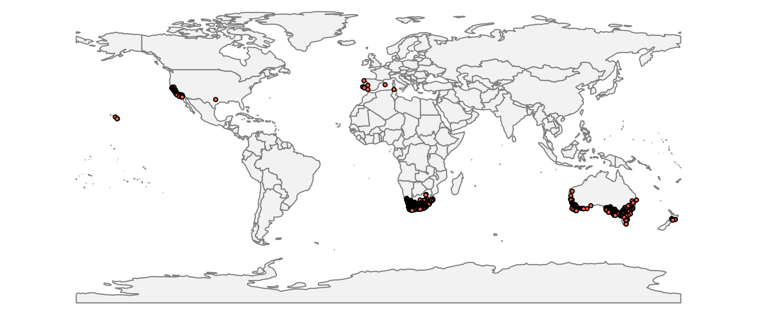

Figure 1. Occurrence records obtained for Ehrharta calycina used in the model.

Species distribution model
A presence-background (presence-only) ensemble modelling strategy was employed using the BIOMOD2 R package v3.3-7 (Thuiller et al., 2014, Thuiller et al., 2009). These models contrast the environment at the species’ occurrence locations against a random sample of the global background environmental conditions (often termed ‘pseudo-absences’) in order to characterise and project suitability for occurrence. This approach has been developed for distributions that are in equilibrium with the environment. Because invasive species’ distributions are not at equilibrium and subject to dispersal constraints at a global scale, we took care to minimise the inclusion of locations suitable for the species but where it has not been able to disperse to. Therefore the background sampling region included:
- The native continents of E. calycina, i.e. Africa, in which the species is likely to have had sufficient time to cross all biogeographical barriers; AND
- A relatively small 50 km buffer around all non-native occurrences, encompassing regions likely to have had high propagule pressure for introduction by humans and/or dispersal of the species; AND
- Regions where we have an a priori expectation of high unsuitability for the species (see Fig. 2). Absence from these regions is considered to be irrespective of dispersal constraints. Since we considered that the native range of the species might not be very informative about low temperature limitation, we specified rules for defining unsuitability based on the two temperature variables:
  - Mean minimum temperature of the coldest month (Bio6) < -5 °C. There is little information on frost tolerance of E. calycina, but the coldest location with a presence in our dataset has Bio6 = -4.9 °C.
  - Mean maximum temperature of the warmest month (Bio5) > 40 °C. We assumed heat stress would limit occurrence above this temperature. Of the 1569 occurrence records for modelling, the hottest has Bio5 = 40.9 °C, but all others have Bio5 < 37.9 °C.
  - Mean maximum temperature of the warmest month (Bio5) < 15 °C. We assumed cold growing season temperatures would limit occurrence below this temperature. Of the 1569 occurrence records for modelling, the coldest has Bio5 = 13.4 °C, but all others have Bio5 < 17.0 °C.
Within this sampling region there will be substantial spatial biases in recording effort, which may interfere with the characterisation of habitat suitability. Specifically, areas with a large amount of recording effort will appear more suitable than those without much recording, regardless of the underlying suitability for occurrence. Therefore, a measure of vascular plant recording effort was made by querying the Global Biodiversity Information Facility application programming interface (API) for the number of phylum Tracheophyta records in each 0.1 x 0.1 degree grid cell (Figure 2). The sampling of background grid cells was then weighted in proportion to the Tracheophyte recording density. Assuming Tracheophyte recording density is proportional to recording effort for the focal species, this is an appropriate null model for the species’ occurrence.

To sample as much of the background environment as possible, without overloading the models with too many pseudo-absences, five background samples of 10,000 randomly chosen grid cells were obtained (Figure 3).

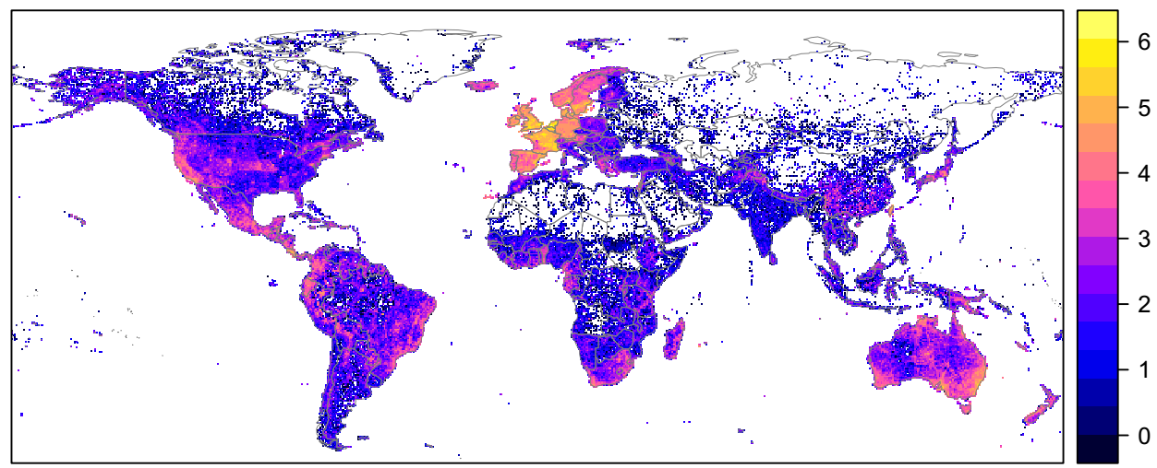

Figure 2. The density of Tracheophyte records held by GBIF, aggregated to a 0.5 x 0.5 degree resolution and log₁₀ transformed. These densities were used to weight the sampling of background locations for modelling to account for recording effort biases.

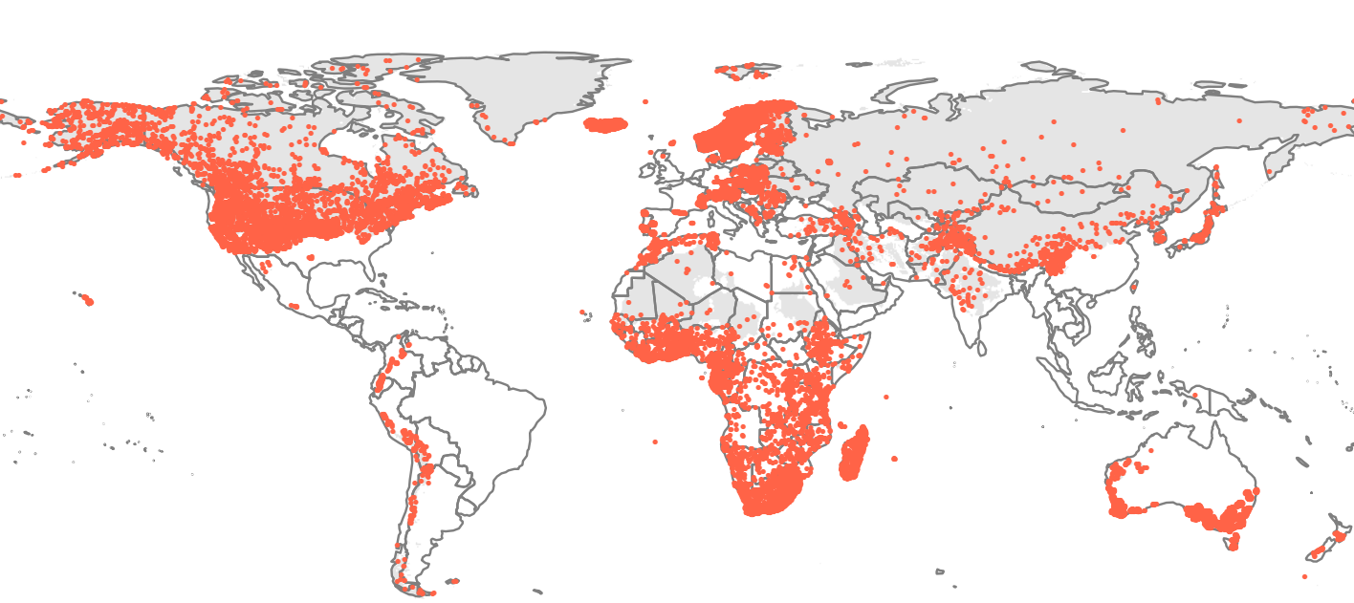

Figure 3. Randomly selected background grid cells used in the modelling of Ehrharta calycina, mapped as red points. Points are sampled from across the native continent (Africa), a small buffer around non-native occurrences and from areas expected to be highly unsuitable for the species (grey background region), and weighted by a proxy for plant recording effort (Figure 2).

Each dataset (i.e. combination of the presences and the individual background samples) was randomly split into 80% for model training and 20% for model evaluation. With each training dataset, ten statistical algorithms were fitted with the default BIOMOD2 settings, except where specified below:
- Generalised linear model (GLM)
- Generalised boosting model (GBM)
- Generalised additive model (GAM) with a maximum of four degrees of freedom per smoothing spline.
- Classification tree algorithm (CTA)
- Artificial neural network (ANN)
- Flexible discriminant analysis (FDA)
- Multivariate adaptive regression splines (MARS)
- Random forest (RF)
- MaxEnt
- Maximum entropy multinomial logistic regression (MEMLR)
Since the background sample was much larger than the number of occurrences, prevalence fitting weights were applied to give equal overall importance to the occurrences and the background. Variable importances were assessed and variable response functions were produced using BIOMOD2’s default procedure. Model predictive performance was assessed by calculating the Area Under the Receiver-Operator Curve (AUC) for model predictions on the evaluation data, that were reserved from model fitting. AUC can be interpreted as the probability that a randomly selected presence has a higher model-predicted suitability than a randomly selected absence. This information was used to combine the predictions of the different algorithms to produce ensemble projections of the model. For this, the three algorithms with the lowest AUC were first rejected and then predictions of the remaining seven algorithms were averaged, weighted by their AUC. Ensemble projections were made for each dataset and then averaged to give an overall suitability.

Results
The ensemble suggested that suitability for E. calycina was most strongly determined by the minimum temperature of the coldest month, the aridity index, maximum temperature of the warmest month and annual precipitation (Table 1). From Figure 4, the ensemble model estimated the optimum conditions for occurrence at approximately:
- Minimum temperature of the coldest month = 9.3 °C (>50% suitability from -3.8 °C to 18.2 °C).
- Aridity index (precipitation:PET) = 0.11 (>50% suitability with < 0.76).
- Maximum temperature of the warmest month = 24.6 °C (>50% suitability from 6.2 to 32.0 °C)
- Annual precipitation = 245 mm (>50% suitability with < 1130 mm).
These optima and ranges of high suitability described above are conditional on the other predictors being at their median value in the data used in model fitting.
The model also characterised weaker preferences for moderately sandy soils (highest suitability with 40-75% sand), an avoidance of extremely low precipitation in the driest quarter and a preference for moderately seasonal precipitation regimes (Table 1, Figure 4).
There was substantial variation among modelling algorithms in the partial response plots (Figure 4). In part this will reflect their different treatment of interactions among variables. Since partial plots are made with other variables held at their median, there may be values of a particular variable at which this does not provide a realistic combination of variables to predict from. It also demonstrates the value of an ensemble modelling approach in averaging out the uncertainty between algorithms.

Global projection of the model in current climatic conditions (Figure 5) indicates that the native distribution and major invasive clusters of records (Australia and California) largely fell within regions predicted to have high suitability. The model predicts that the climate may permit some further expansion of the species’ distributions in Australia and North America. Other major regions without records of the species, but that are projected to be climatically suitable include southern and western Argentina, southern Bolivia, northern Chile, coastal Peru, parts of Yemen and Somalia and coastal Namibia.

The projection of suitability in Europe and the Mediterranean region revealed that the main cluster of records in Portugal was in a region predicted to be suitable (Figure 6). However, the isolated records in Spain and Tunisia were modelled as within climatically unsuitable regions, albeit with the Menorcan record predicted to be marginally suitable. There were other significant areas predicted to be suitable in Spain, the Canary Islands, Morocco, Algeria, Tunisia, Libya and Egypt. Small potentially suitable areas were predicted for parts of Italy (especially Sardinia) and France (Corsica). Outside of the Mediterranean region, there was a very small region predicted to have marginal suitability in Germany, which seems inconsistent with the species’ accepted preference for Mediterranean climates and may be a statistical artefact of the particular variables used in the modelling.

By the 2070s, under climate change scenario RCP8.5, almost no parts of southern Europe and the Mediterranean region were predicted to remain or become suitable for E. calycina (Figure 7). Examination of the future climate scenario data suggest that this was driven by an increase in maximum temperature of the warmest month to levels at which the model suggests it can limit occurrence of the E. calycina (Figure 4). The only part of Europe predicted to retain climatic suitability was the Canary Islands. In northern Europe suitability was predicted to increase by the 2070s, but largely remain marginally unsuitable for E. calycina (Figure 7). The small pocket of Germany predicted as currently suitable was predicted to remain so in the 2070s and small pockets of suitable climates now appear in south eastern UK, and the south eastern coast of Sweden, though the latter are difficult to see in Figure 7 because of the smoothing. Table 1. Summary of the cross-validation predictive performance (AUC) and variable importances of the fitted model algorithms and the ensemble (AUC-weighted average of the best performing seven algorithms). Results are the average from models fitted to five different background samples of the data.

Algorithm | AUC | Variable importance
Algorithm | AUC | Minimum temperature of coldest month | Maximum temperature of warmest month | Annual precipitation | Precipitation of driest quarter | Precipitation seasonality | Aridity index | Soil sand content
ANN | 0.9414 | 37.6% | 14.0% | 18.3% | 8.8% | 6.3% | 13.0% | 2.0%
GBM | 0.9408 | 76.8% | 6.0% | 13.1% | 0.2% | 1.4% | 0.6% | 1.9%
MaxEnt | 0.9346 | 42.2% | 14.2% | 11.1% | 2.9% | 2.4% | 22.6% | 4.7%
GAM | 0.9336 | 54.5% | 9.4% | 9.2% | 3.0% | 2.4% | 19.7% | 1.8%
MARS | 0.9336 | 53.9% | 9.7% | 1.5% | 0.0% | 0.7% | 32.5% | 1.6%
GLM | 0.9300 | 50.7% | 8.1% | 2.3% | 3.2% | 2.0% | 31.7% | 2.0%
RF | 0.9292 | 42.3% | 12.8% | 10.1% | 5.0% | 6.0% | 11.9% | 11.9%
FDA | 0.9220 | 23.5% | 14.8% | 2.9% | 0.0% | 2.5% | 53.0% | 3.3%
MEMLR | 0.9122 | 18.8% | 16.3% | 4.5% | 5.1% | 0.2% | 54.5% | 0.7%
CTA | 0.9110 | 53.3% | 7.9% | 21.7% | 1.9% | 6.5% | 2.0% | 6.6%
Ensemble | 0.9414 | 51.2% | 10.6% | 9.4% | 3.3% | 3.0% | 18.8% | 3.7%

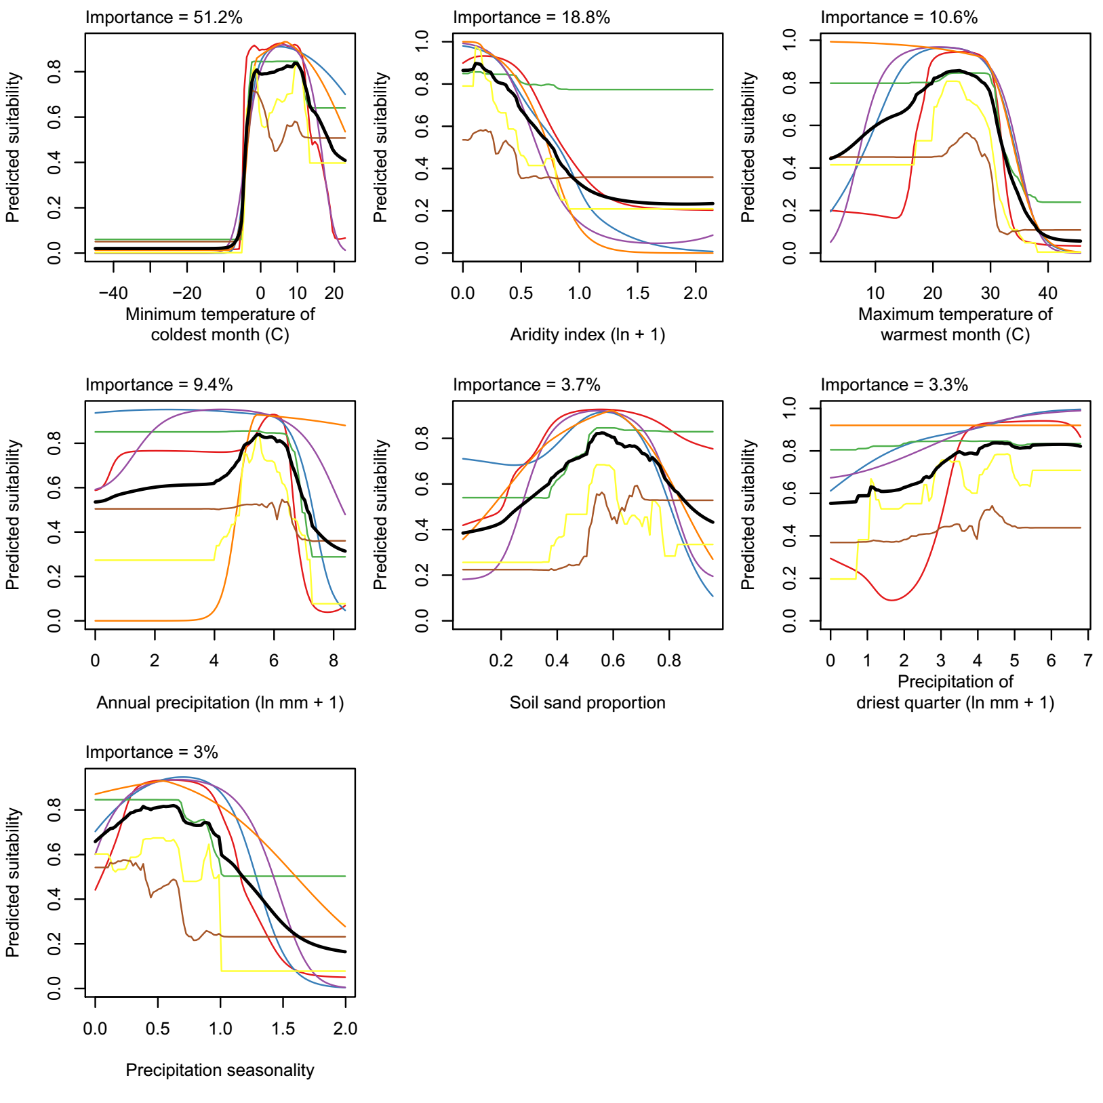
Figure 4. Partial response plots from the fitted models, ordered from most to least important. Thin coloured lines show responses from the seven algorithms, while the thick black line is their ensemble. In each plot, other model variables are held at their median value in the training data. Some of the divergence among algorithms is because of their different treatment of interactions among variables.

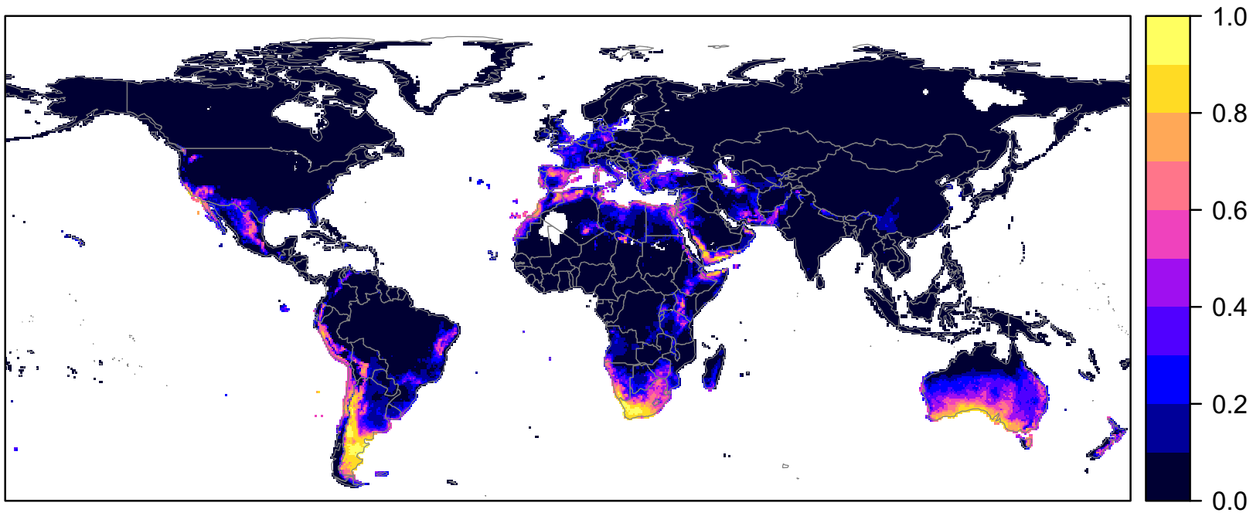
Figure 5. Projected global suitability for Ehrharta calycina establishment in the current climate (1960-1990). For visualisation, the projection has been aggregated to a 0.5 x 0.5 degree resolution, by taking the maximum suitability of constituent higher resolution grid cells. Values > 0.5 may be suitable for the species. The white areas have climatic conditions outside the range of the training data so were excluded from the projection.

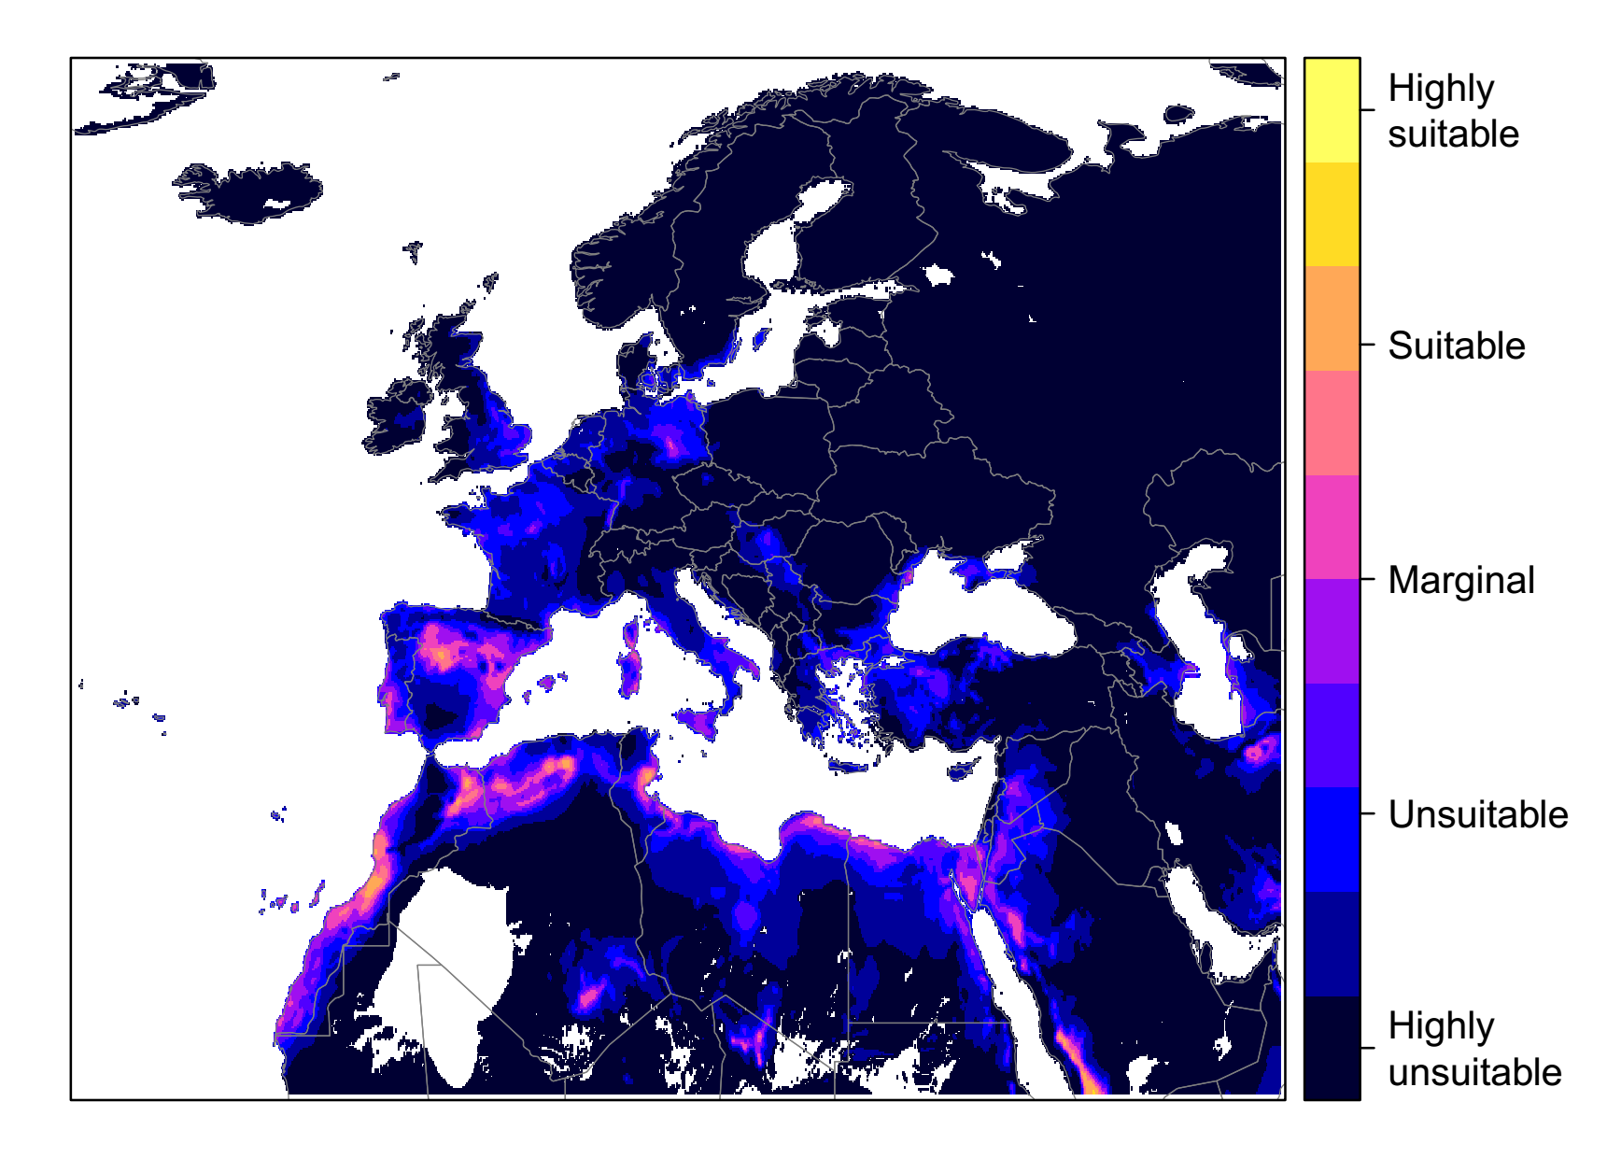

Figure 6. Projected current suitability for Ehrharta calycina establishment in Europe and the Mediterranean region. For visualisation, the projected suitability has been smoothed with a Gaussian filter with standard deviation of 0.1 degrees longitude/latitude. The white areas have climatic conditions outside the range of the training data so were excluded from the projection.
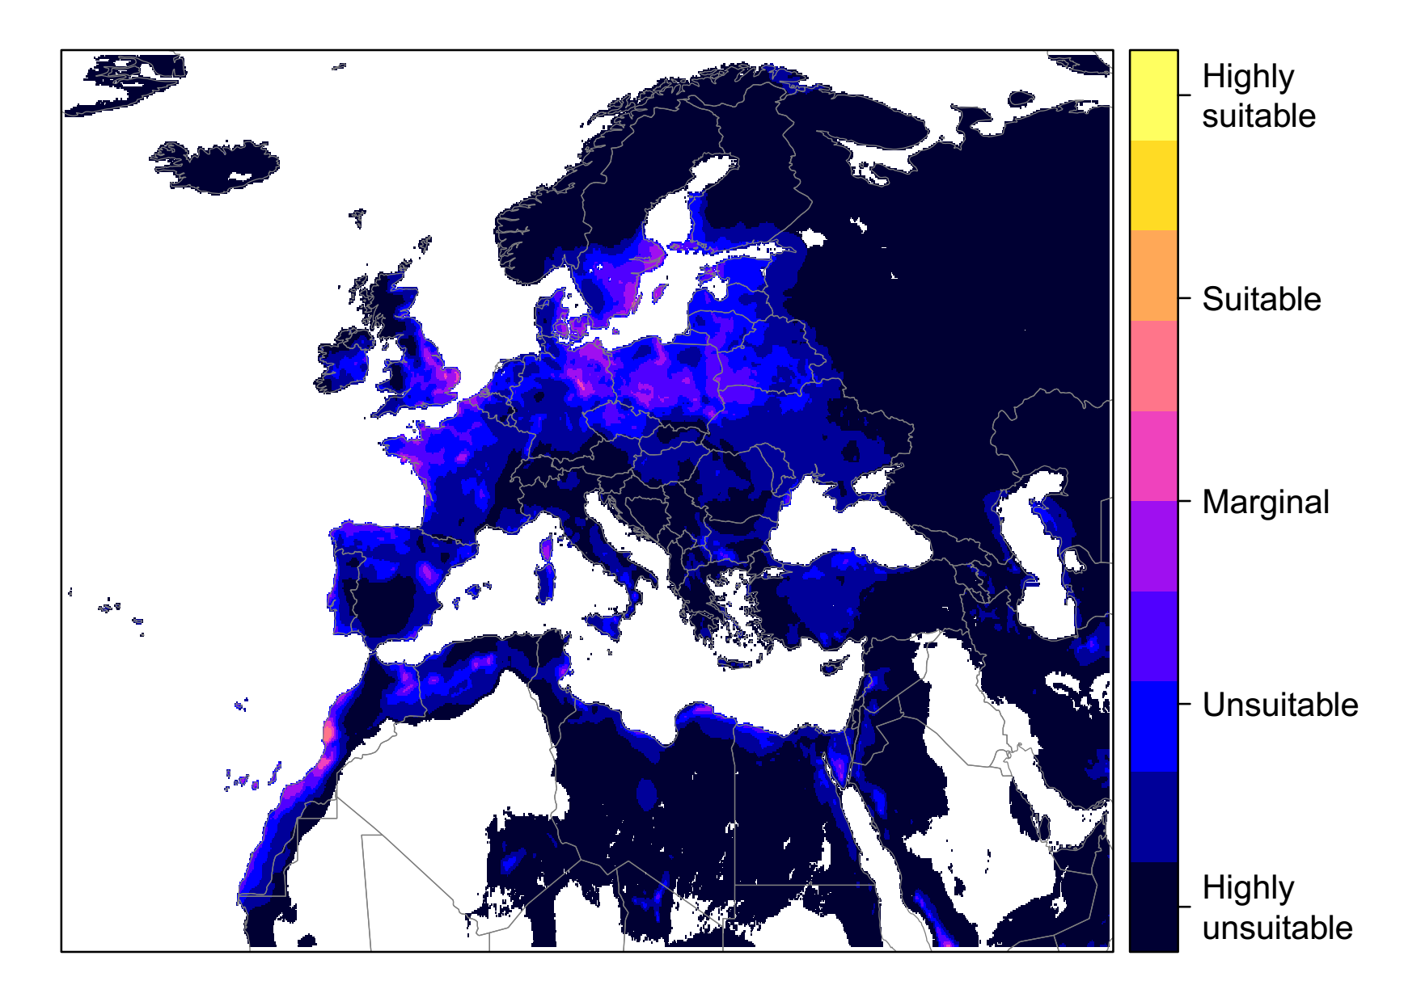

Figure 7. Projected suitability for Ehrharta calycina establishment in Europe and the Mediterranean region in the 2070s under climate change scenario RCP8.5, equivalent to Fig. 5.
Caveats to the modelling
As described above, the high resolution of the model (0.1 x 0.1 degree) exceeded the precision of many records from the native range. This may cause the model to over-predict the climatic tolerances of the species.

To remove spatial recording biases, the selection of the background sample was weighted by the density of Tracheophyte records on the Global Biodiversity Information Facility (GBIF). While this is preferable to not accounting for recording bias at all, a number of factors mean this may not be the perfect null model for species occurrence:

- The GBIF API query used to did not appear to give completely accurate results. For example, in a small number of cases, GBIF indicated no Tracheophyte records in grid cells in which it also yielded records of the focal species.
- We located additional data sources to GBIF, which may have been from regions without GBIF records.
The nature of the species’ distribution may have meant the model was not well-trained for the likely limits on the species’ distribution in Europe:
- We made quite strong assumptions about the limits to extreme minimum and maximum temperatures, based on the current distribution records. If the species is still actively expanding its range in North America or Australia and has not yet reached its climatic range limits then this will cause the model to under-predict the potentially-invaded range in Europe.
- The model predicts southern Europe to become too hot in summer for the species by the late 21st century. However, the model training data mainly observed very hot conditions in tropical Africa rather than in Mediterranean-type climates. It is unclear whether higher temperatures in Mediterranean Europe would limit the species occurrence in reality.
- The prediction of suitability in small areas of northern Europe may be regarded as highly uncertain because of the species known preference for Mediterranean climates. The sampling of background pseudo-absence points did not sample extensively from temperate northern Europe (Figure 3) because we could not be certain on an a priori basis that absence from these regions was because of climatic unsuitability rather than other explanations such as lack of propagule pressure. Therefore the model may not have properly represented responses to northern European climate gradients.
Other variables potentially affecting the distribution of the species, such as soil nutrients and land use, were not included in the model.

The climate change scenario used is the most extreme of the four RCPs. However, it is also the most consistent with recent emissions trends and could be seen as worst case scenario for informing risk assessment.

References
R. J. Hijmans, S. E. Cameron, J. L. Parra, P. G. Jones & A. Jarvis (2005) Very high resolution interpolated climate surfaces for global land areas. International Journal of Climatology 25, 1965-1978.
R. J. Zomer, A. Trabucco, D. A. Bossio & L. V. Verchot (2008) Climate change mitigation: A spatial analysis of global land suitability for clean development mechanism afforestation and reforestation. Agriculture, Ecosystems & Environment 126, 67-80.
G. H. Hargreaves (1994) Defining and Using Reference Evapotranspiration. Journal of Irrigation and Drainage Engineering 120.
T. Hengl, J. M. de Jesus, R. A. MacMillan, N. H. Batjes, G. B. Heuvelink, E. Ribeiro, A. Samuel-Rosa, B. Kempen, J. G. Leenaars & M. G. Walsh (2014) SoilGrids1km—global soil information based on automated mapping. PLoS One 9, e105992.
W. Thuiller, D. Georges & R. Engler (2014) biomod2: Ensemble platform for species distribution modeling. R package version 3.3-7 Available at: https://cran.r-project.org/web/packages/biomod2/index.html.
W. Thuiller, B. Lafourcade, R. Engler & M. B. Araújo (2009) BIOMOD–a platform for ensemble forecasting of species distributions. Ecography 32, 369-373.

Appendix 2. Biogeographic regions in Europe

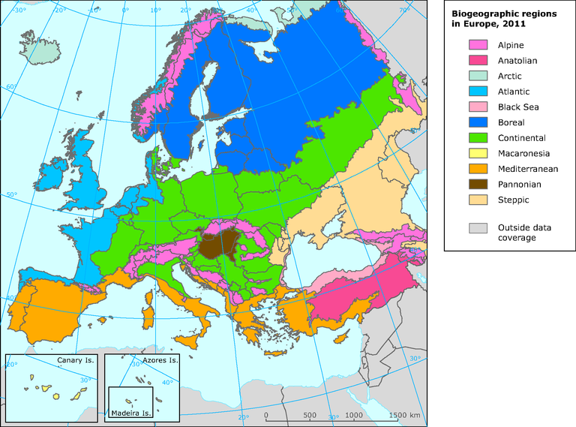

Appendix 3. Relevant illustrative pictures (for information)

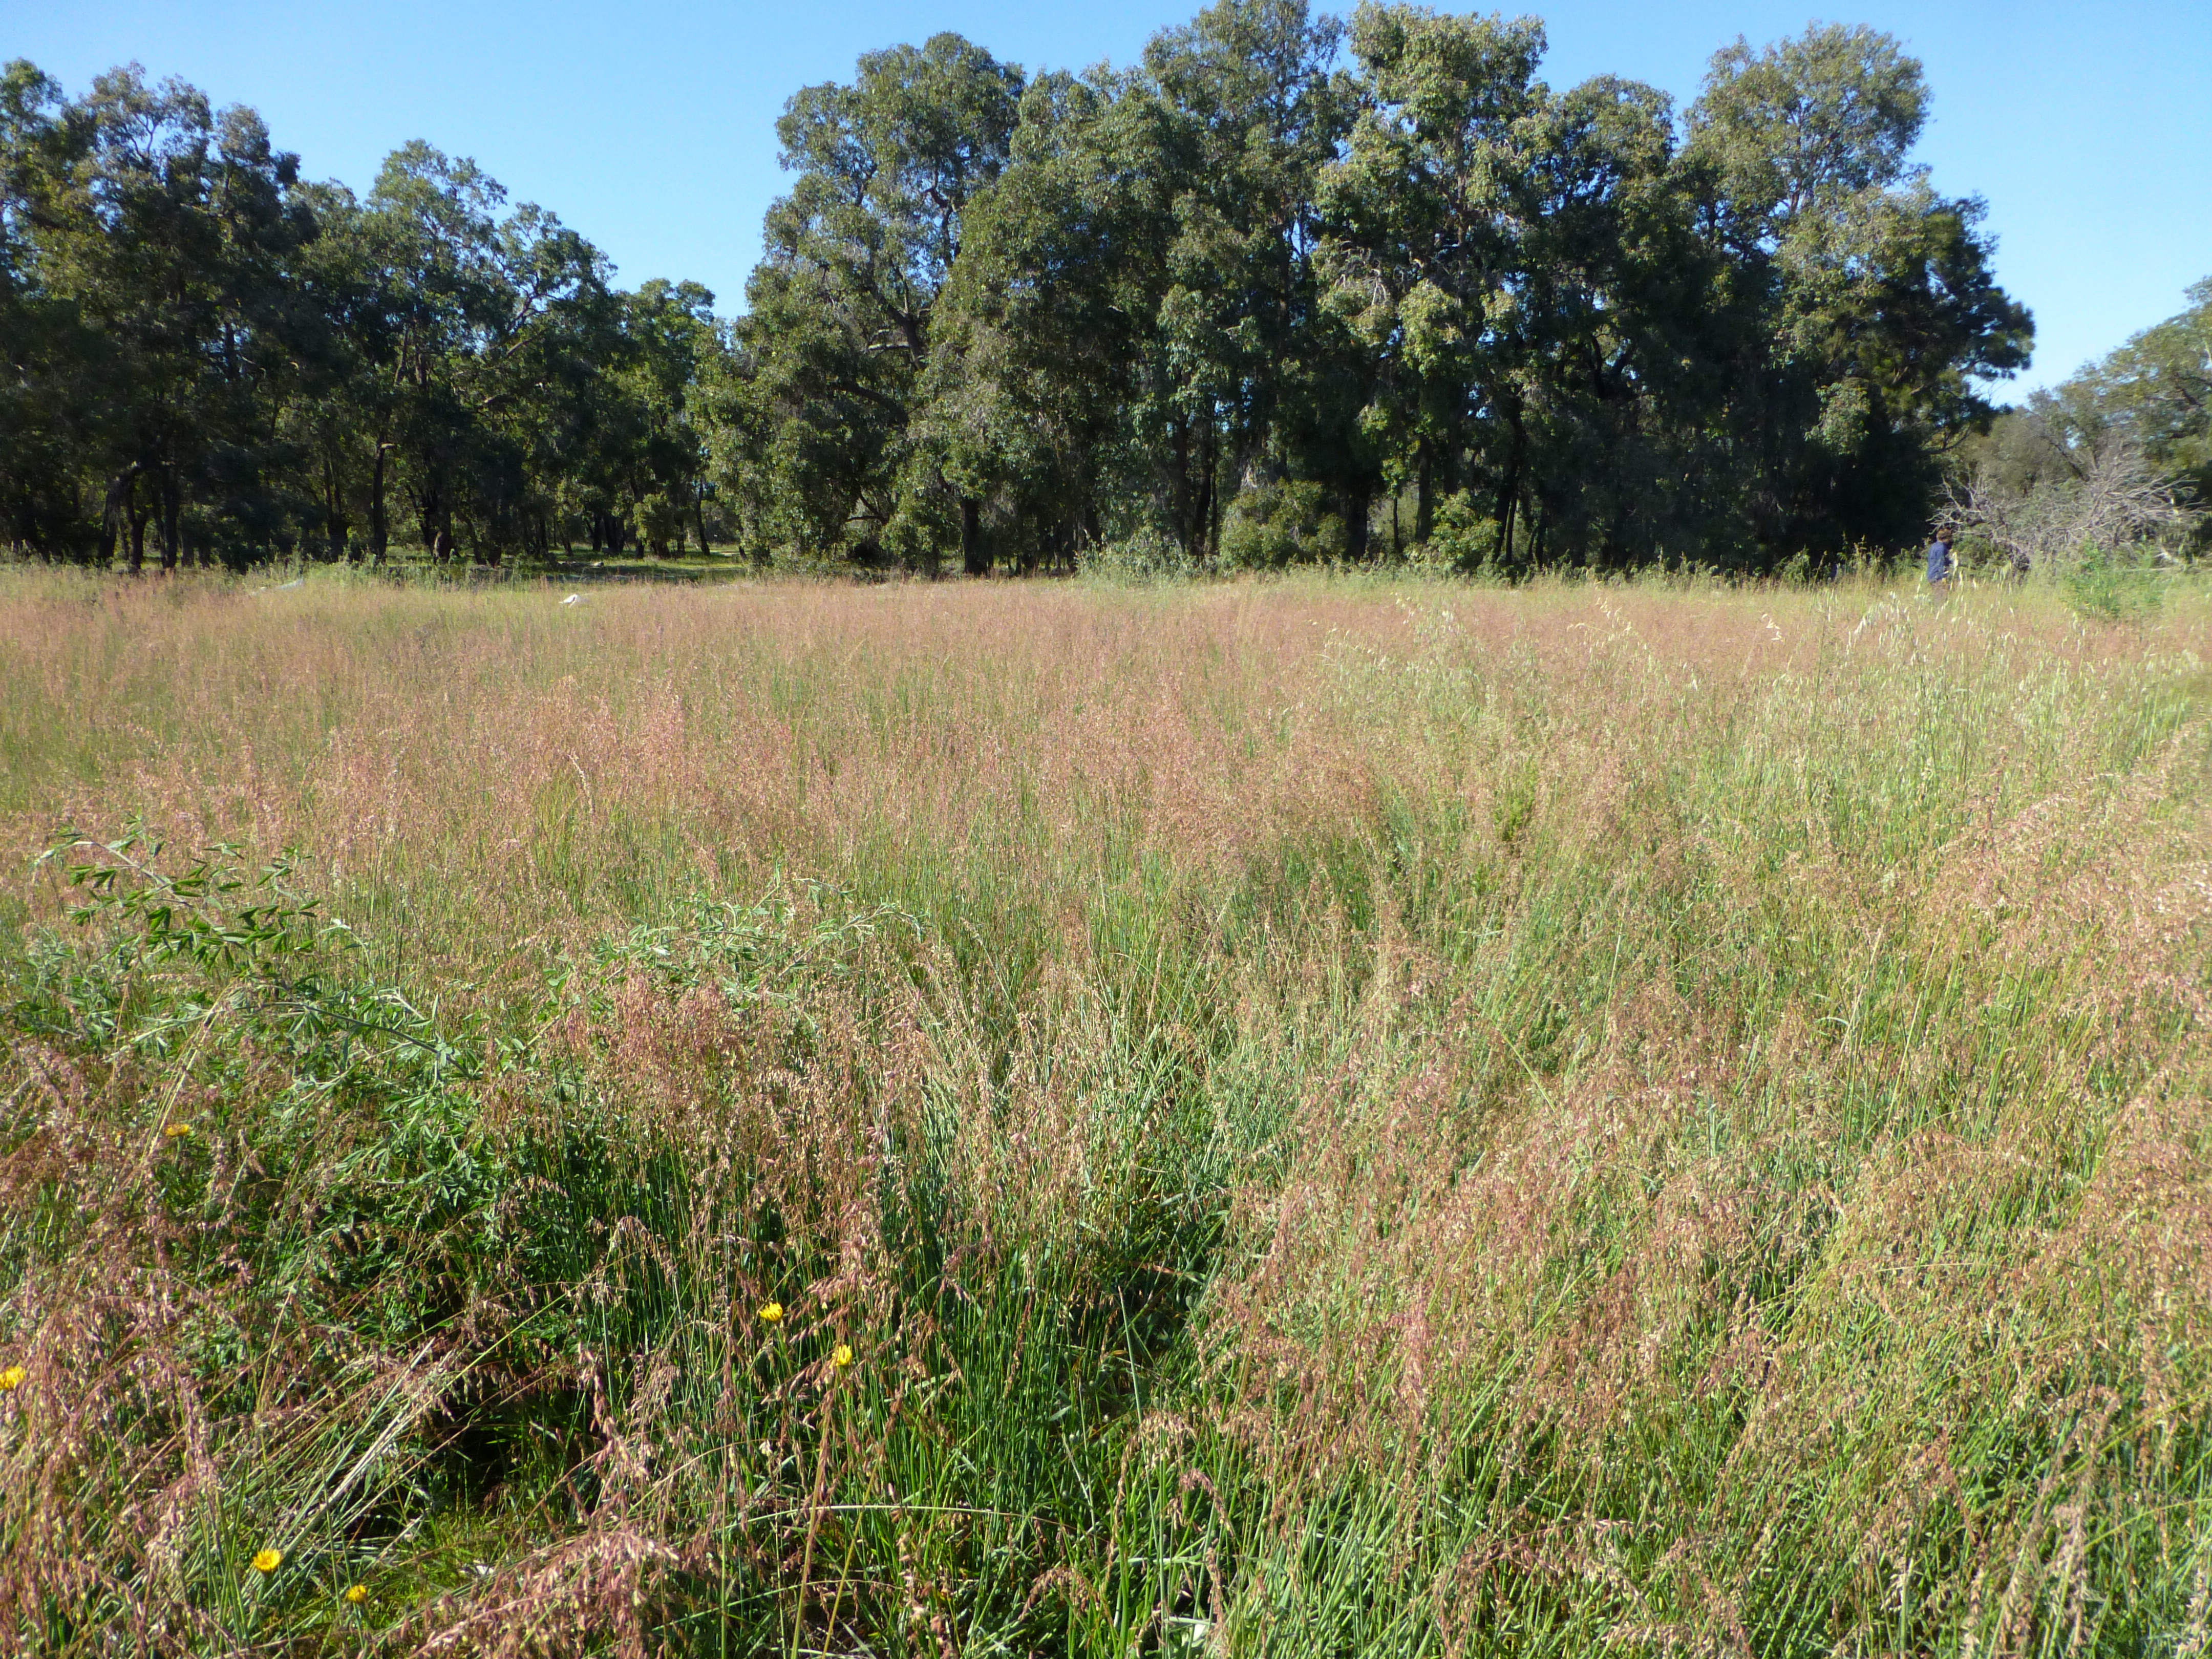

Figure 1: Ehrharta calycina invading grassland in Australia (Image: Sian Mawson)

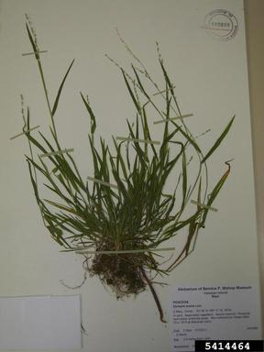

Figure 2: Herbarium specimen of Ehrharta calycina

Appendix 4: Distribution summary for EU Member States and Biogeographical regions
Member States:
 | Recorded | Established (currently) | Established (future) | Invasive (currently)
Austria | – | – | – | –
Belgium | – | – | – | –
Bulgaria | – | – | – | –
Croatia | – | –
Cyprus | – | – | – | –
Czech Republic | – | – | – | –
Denmark | – | – | – | –
Estonia | – | – | – | –
Finland | – | – | – | –
France | – | – | – | –
Germany | – | – | YES | –
Greece | – | – | – | –
Hungary | – | – | – | –
Ireland | – | – | – | –
Italy | – | – | YES | –
Latvia | – | – | – | –
Lithuania | – | – | – | –
Luxembourg | – | – | – | –
Malta | – | – | – | –
Netherlands | – | – | – | –
Poland | – | – | – | –
Portugal | YES | YES | – | –
Romania | – | – | – | –
Slovakia | – | – | – | –
Slovenia | – | – | – | –
Spain | YES | YES |  | –
Sweden | – | – | YES | –
United Kingdom | – | – | YES | –

Biogeographical regions
 | Recorded | Established (currently) | Established (future) | Invasive (currently)
Alpine | – | – | – | –
Atlantic | – | YES | YES | –
Black Sea | – | – |  | –
Boreal | – | – | YES | –
Continental | – | – | YES | –
Mediterranean | – | YES | YES | –
Pannonian | – | – | – | –
Steppic | – | – | – | –

YES: if recorded in natural environment, established or invasive or can occur under future climate; – if not recorded, established or invasive; ? Unknown

Appendix 5 Distribution maps for Ehrharta calycina
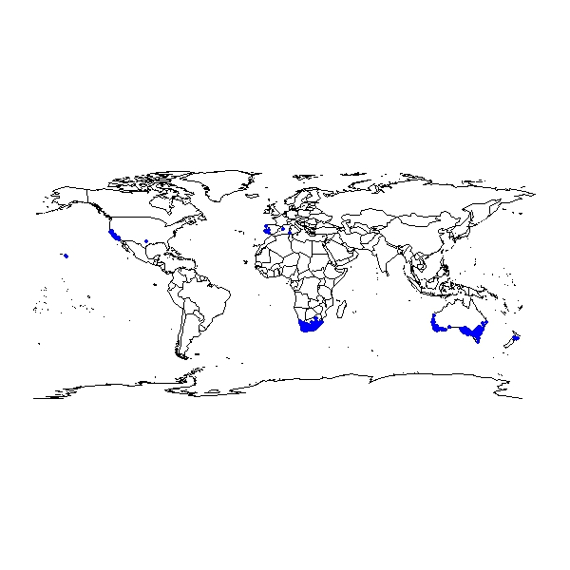

Figure 1. Global distribution of Ehrharta calycina

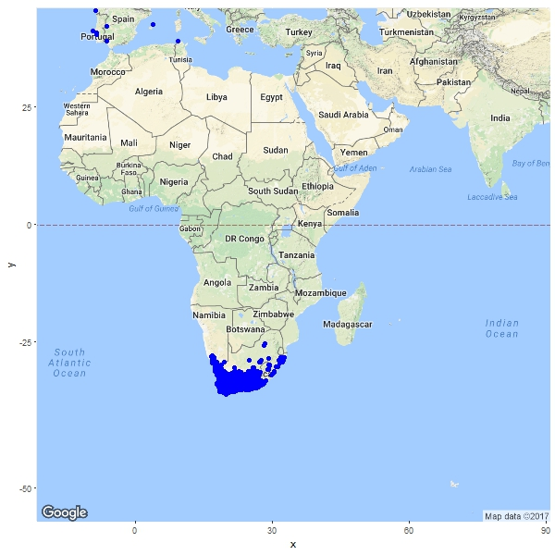

Figure 2. Occurrence of Ehrharta calycina in Africa

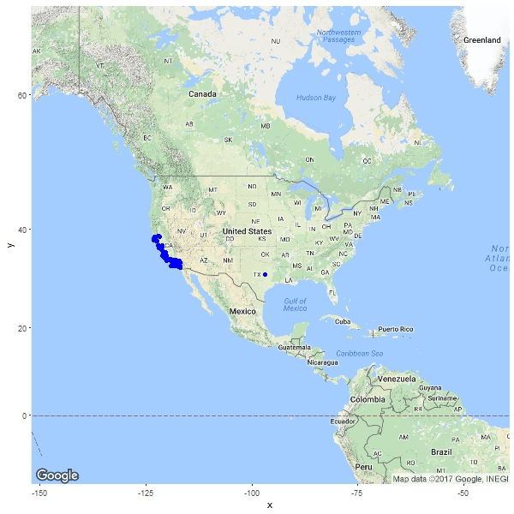

Figure 3. Occurrence of Ehrharta calycina in North America

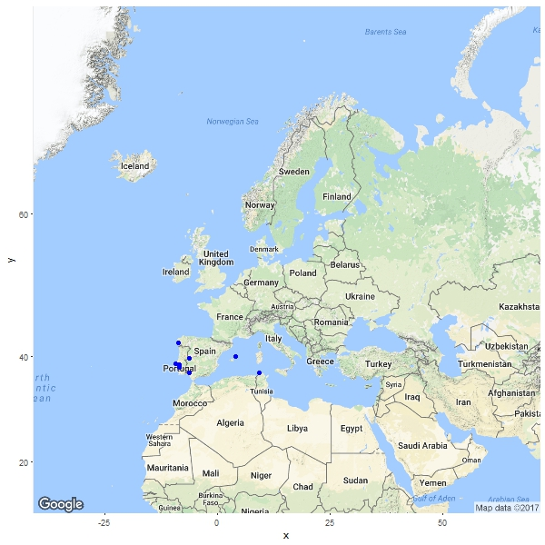

Figure 4. Occurrence of Ehrharta calycina in Europe

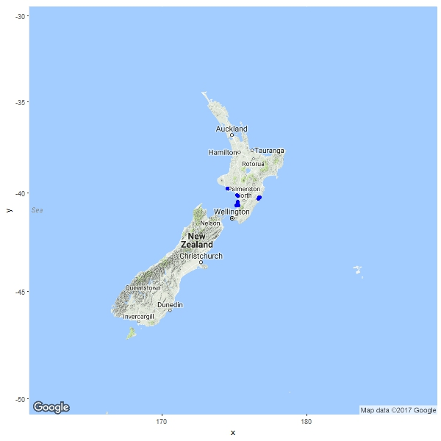

Figure 5. Occurrence of Ehrharta calycina in New Zealand

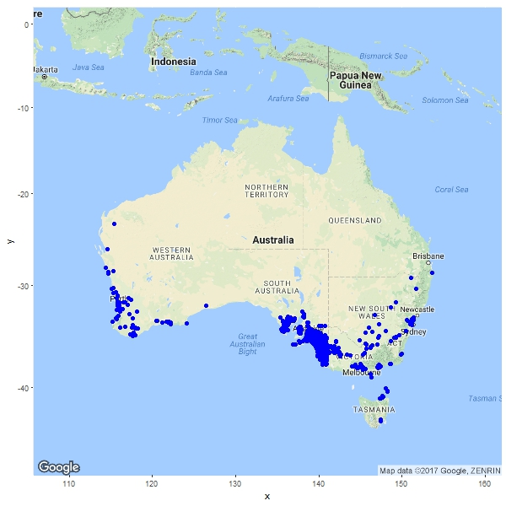

Figure 6. Occurrence of Ehrharta calycina in Australia

The summary should be elaborated once the analysis is completed
http://ec.europa.eu/environment/nature/invasivealien/docs/Prioritising%20prevention%20efforts%20through%20horizon%20scanning.pdf
See also appendix 4: Distribution summary for EU Member States and Biogeographical regions
Note that these maps may contain records, e.g. herbarium records, that were not considered during the climate modelling stage. Date to compile the maps were taken from various sources including GBIF, scientific literature and grey material.

